Software Design Specification

AI Powered Hospital Information Management System

Project Code:

HIMS-AI-2526

Internal Advisor:

Mr. Aamir Zia

Project Manager:

Dr. Muhammad Ilyas

Project Team:
Ali Akbar BSCS51F22R036 (TL)
Muhammad Najee Ullah Noon BSCS51F22S043

Submission Date:

Dec 15, 2025



___________________
Project Manager’s Signature

Document Information

Category | Information
Customer | Computer Science , University Of Sargodha
Project | <Hospital Information Management System >
Document | Requirement Specifications
Document Version | 1.0
Identifier | HIMS-AI-2526
Status | Draft
Author(s) | Ali Akbar  Muhammad Najee Ullah Noon
Approver(s) | PM
Issue Date | Dec. 15, 2025
Document Location
Distribution | - Advisor  - Project Manager  - Project Office

Definition of Terms, Acronyms and Abbreviations

Term | Description
HIMS | Hospital Information Management System
RS | Requirements Specifications
HIPPA | Health Insurance Portability and Accountability Act
GDPR | General Data Protection Regulation
LAN | Local Area Network
CNIC | Computerized National Identity Card

Table of Contents

1. Introduction 4
1.1 Purpose of Document 4
1.2 Project Overview 4
1.3 Scope 5
2. Design Considerations 7
2.1 Assumptions and Dependencies 7
2.2 Risks and Volatile Areas 7
3. System Architecture 9
3.1 System Level Architecture 10
3.2 Sub-System / Component / Module Level Architecture 11
3.3 Sub-Component / Sub-Module Level Architecture (1…n) 12
4. Design Strategies 17
5. Detailed System Design 21
6. References 42

Introduction

  - Purpose of Document
The document presents the design requirements of the project “AI Powered Hospital Information Management System”. It gives a detailed explanation of system’s functionality, its design and how the AI-based solution will automate the patient data management and streamline hospital workflows. Audience covers the project stakeholders, developers, healthcare IT managers and hospital administrators. It serves as reference to ensure that all parties have a unified understanding of the system’s objectives, architecture, constraints and operational behaviors. The document also ensures that the design aligns with HIPPA and GDPR. It will act as a guide during development, testing and deployment phases ensuring that the final product fulfills its intended purpose of reducing administrative burden and improving hospital efficiency.

  - Project Overview
Modern hospitals often struggle with inefficiencies caused by manual data entry, fragmented record-keeping, and time-consuming administrative processes. These challenges lead to delays in patient care, errors in documentation, and an increased workload on medical staff.
To address these issues, the AI-Powered Hospital Information Management System (HIMS) is proposed as an intelligent, automated platform that integrates speech recognition and natural language processing to streamline hospital workflows.
The system functions as follows:
- AI-Based Conversation Recording and Analysis:
The system listens to doctor–patient interactions in real time, identifies the speaker, and extracts key medical information such as symptoms, diagnosis, prescribed treatments, and follow-up details.
- Doctor Confirmation and Data Storage:
Before saving, the extracted data is displayed to the doctor for verification. Once confirmed, it is automatically stored in a centralized hospital database.
- Dedicated Dashboards:
- Doctor Dashboard: Enables doctors to view patient histories, review notes, and manage consultations.
- Admin Dashboard: Allows hospital administrators to manage records, monitor data flow, and ensure system compliance.
- Patient Portal: Provides patients with access to their medical history, prescriptions, and reports.
The core objective of this project is to reduce administrative workload, improve record accuracy, and enable real-time access to patient information. By leveraging advanced technologies such as Whisper for speech-to-text processing, GPT-based models for data extraction, and PostgreSQL for secure data management, the proposed system enhances hospital efficiency and promotes the adoption of AI-driven healthcare solutions.

  - Scope
The scope of the AI-powered Hospital Information Management System (HIMS) is defined by its focus on improving patient record management, reducing administrative workload, and supporting accurate medical documentation through AI assistance, while keeping doctors in control of validation. The project is specifically designed for healthcare institutions and has clear boundaries on what it will and will not cover.
Inclusions (What the System Will Do):
- AI-Assisted Medical Note Creation: “The system captures doctor-patient conversations, highlights relevant medical details (symptoms, diagnoses, tests), and presents them for doctor confirmation before saving to the database [4].”
- Smart Appointment and Queue Management: Patients can book appointments on a first-come-first-serve basis and monitor their queue position in real-time to minimize hospital waiting time and overcrowding.
- Controlled Patient Self-Registration: Patients can create their own accounts through the registration system; however, the accounts will remain inactive until verified and approved by authorized hospital staff to ensure security and authenticity of patient information.
- Centralized Patient Record Management: Hospitals can maintain structured medical histories, accessible to authorized staff across visits.
- Prescription Management System: The platform stores doctor-specific prescription history, allowing healthcare providers to review previous medications and treatment records for continuity of care.
- Integrated Staff Dashboard: Enables staff to verify or edit AI-suggested notes, manage patient data, and oversee hospital operations such as scheduling and reporting.
- Integrated Communication Module: The system provides a secure messaging platform for healthcare-related communication, follow-ups, notifications, and information exchange within the hospital management environment.
- Secure Patient Access: Patients can receive their reports digitally through their profile or via staff-provided printed documents.
- Transparent Billing and Report Access: Patients can access billing information, payment details, and downloadable medical reports digitally through their accounts.
- Healthcare Data Analysis: Aggregated hospital data can be used to analyze patient trends, workload distribution, consultation frequency, and operational efficiency.
Exclusions (What the System Will Not Do):
- Autonomous Medical Decision-Making: The system will not independently diagnose diseases, prescribe medicines, or recommend treatments without doctor involvement and approval.
- Cross-Hospital Data Sharing: Patient data will not automatically transfer between hospitals unless formally integrated with external systems.
- Non-Medical Hospital Operations: The system will not handle unrelated tasks such as payroll, pharmacy stock management, or facility maintenance.
- Emergency Response Management: The platform is not intended to function as an emergency dispatch or ambulance coordination system.
- Advanced AI Disease Prediction: The current version of the system will not include predictive analytics for disease forecasting or automated medical risk assessment.
- Multilingual Limitation: The system currently supports English, Urdu, and Punjabi only and does not provide support for additional regional or international languages in the present implementation.

Design Considerations

  - Assumptions and Dependencies

Assumptions
- The hospital’s medical staff and administrative personnel will cooperate fully in adopting the new HIMS platform and provide accurate input data during initial setup and daily usage.
- The hospital’s existing hardware infrastructure (computers, microphones, and secure servers) will meet the minimum system requirements for smooth operation.
- Internet connectivity within the hospital premises will remain stable to enable real-time data synchronization and AI model processing.
- Doctor-patient conversation recordings will be conducted in environments with minimal background noise to ensure the accuracy of the speech-to-text and entity extraction modules.
- All users—including doctors, nurses, and administrative staff—will receive basic training on how to use the system effectively.
- The hospital’s policies and workflows will remain consistent during the system’s development and deployment phases, ensuring alignment between technical and operational procedures.

Dependencies
- The AI modules depend on external speech-to-text and natural language processing APIs for transcribing and extracting key medical data from doctor-patient conversations.
- The system relies on a stable connection to the hospital’s central database for data storage and retrieval of patient records, diagnoses, and treatment histories.
- Regular data updates and maintenance must be performed by authorized IT personnel to ensure accuracy and prevent inconsistencies.
- Integration with existing hospital modules (e.g., billing, pharmacy, and lab systems) depends on the availability and compatibility of their APIs or export functionalities.
- The system’s deployment and maintenance depend on compliance with healthcare regulations such as HIPAA or local data protection laws to ensure security and confidentiality.
- Timely software updates, API key renewals, and support from external AI service providers are necessary to maintain full functionality and performance.

  - Risks and Volatile Areas

1. Integration with External Systems
Risk: The system may require integration with external services such as speech recognition (ASR), NLP engines, email services, or future healthcare APIs. Changes in external APIs or protocols may affect system functionality.
Design Response:
- Use modular API integration architecture.
- Define clear API communication interfaces.
- Separate external service logic from core system modules to simplify future updates and maintenance.

2. Technology and Infrastructure Changes
Risk: Future upgrades in databases, hosting environments, or software frameworks may impact system compatibility and performance.
Design Response:
- Use a layered system architecture for easier maintenance and upgrades.
- Apply database abstraction through Django ORM.
- Maintain modular backend and frontend components to support future scalability.

3. Performance and Scalability Demands
Risk: Increasing patient records, concurrent users, and AI-based voice processing may reduce system performance.
Design Response:
- Optimize database queries and API responses.
- Use efficient data caching where necessary.
- Process voice transcription and report generation efficiently to reduce server load.

4. Security Threats
Risk: Unauthorized access, data breaches, or misuse of sensitive patient information may compromise system security.
Design Response:
- Implement role-based access control for different user types.
- Encrypt sensitive data during transmission and storage.
- Use secure authentication and session management mechanisms.
- Regularly monitor and update system security measures.

5. Third-Party Service Dependency Risks
Risk: External services such as ASR engines, cloud storage, or email gateways may experience downtime or API changes.
Design Response:
- Design the system with replaceable service integration modules.
- Implement proper error handling and retry mechanisms.
- Maintain backup configurations for critical external services when possible.

6. Operational Risks
Risk: Server failures, internet connectivity issues, or database errors may interrupt hospital operations.
Design Response:
- Maintain regular database backups.
- Implement recovery mechanisms for critical data.
- Monitor server health and system availability.
- Use reliable hosting infrastructure to minimize downtime.

System Architecture

3.0 Use Case Diagram

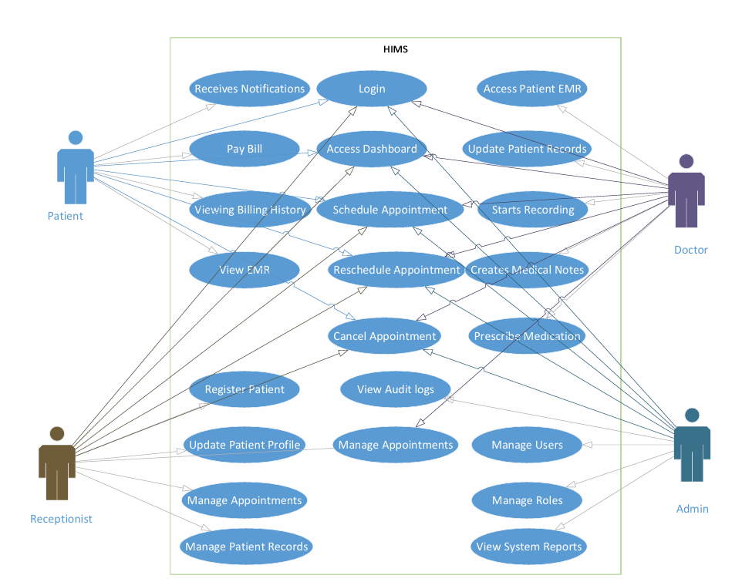
Figure 3.0 Use Case Diagram
  - System Level Architecture
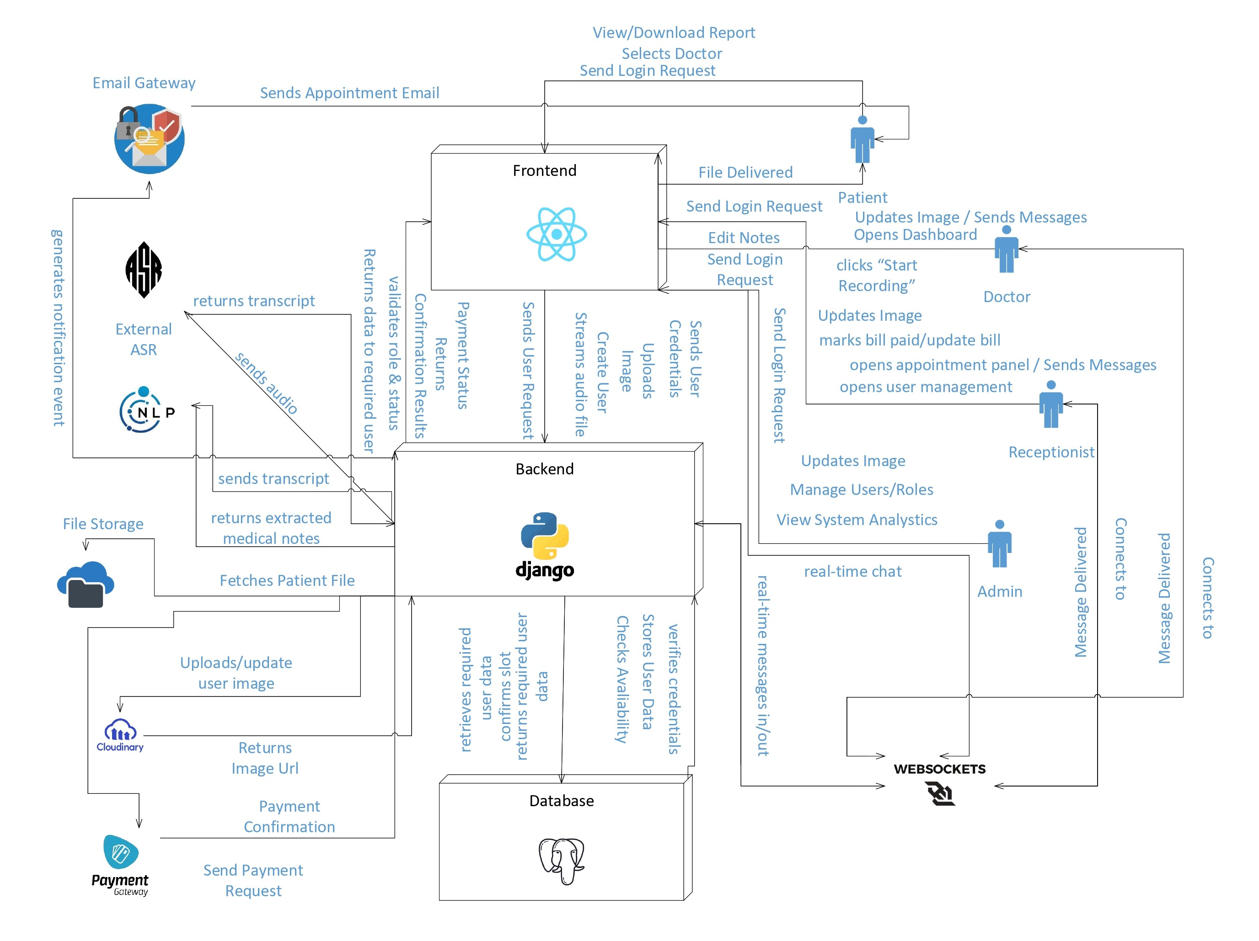
Figure 3.1 System Architecture Diagram

  - Sub-System / Component / Module Level Architecture
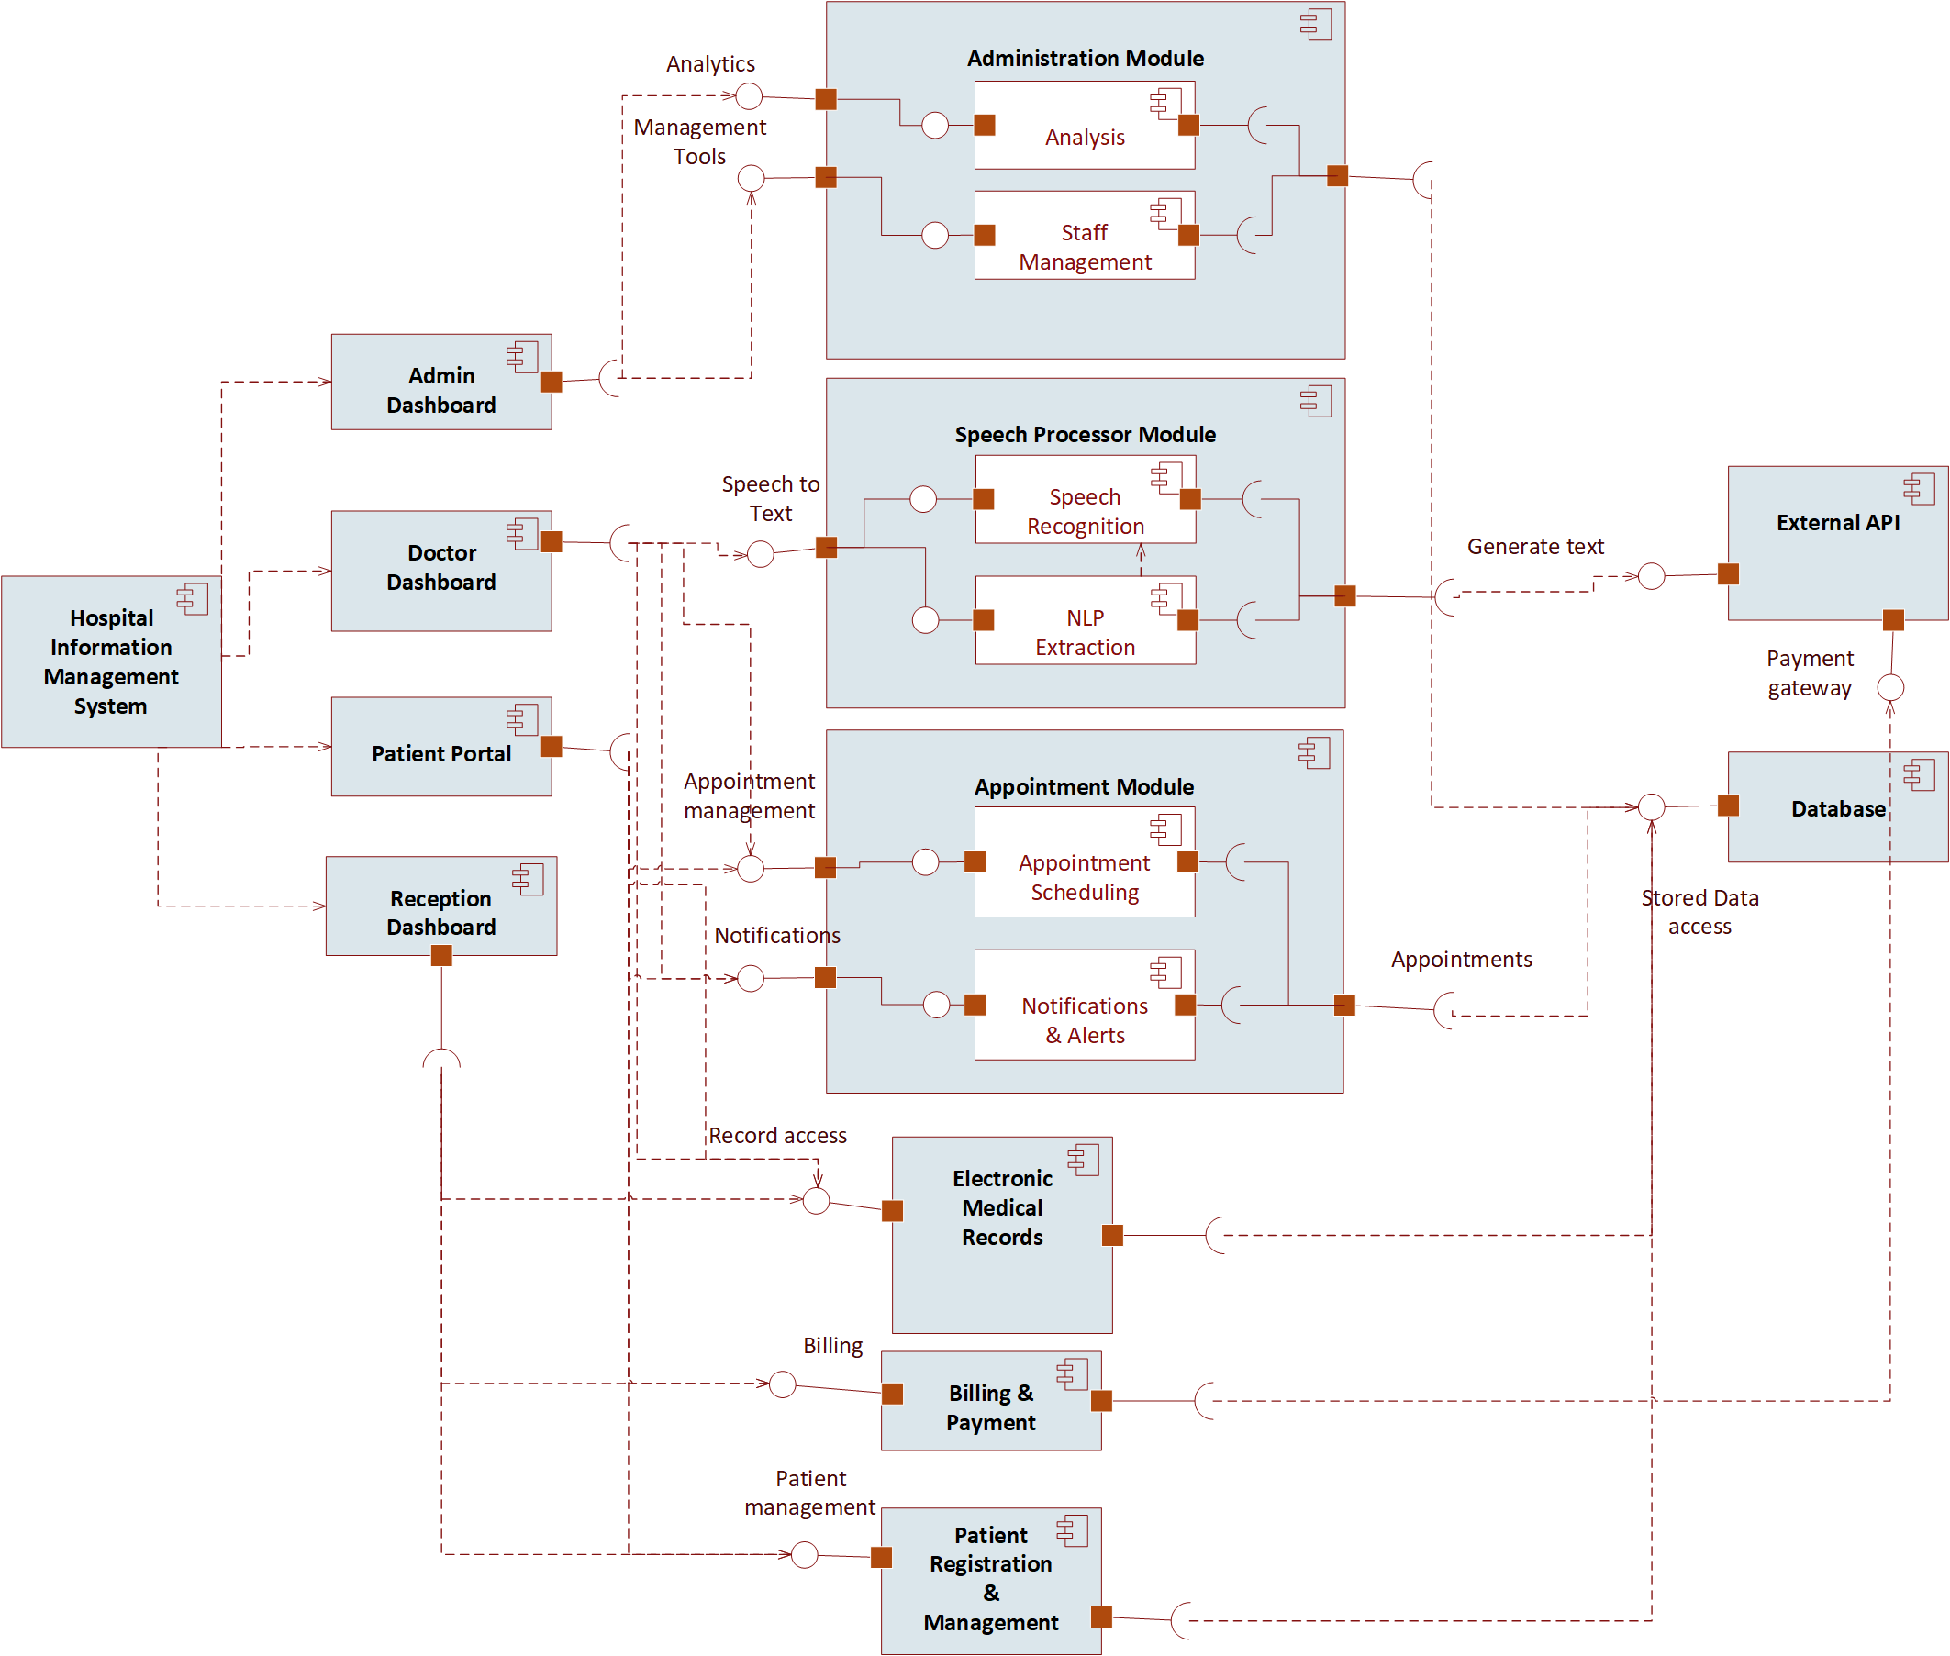

Figure 3.2 Component Diagram

  - Sub-Component / Sub-Module Level Architecture (1…n)
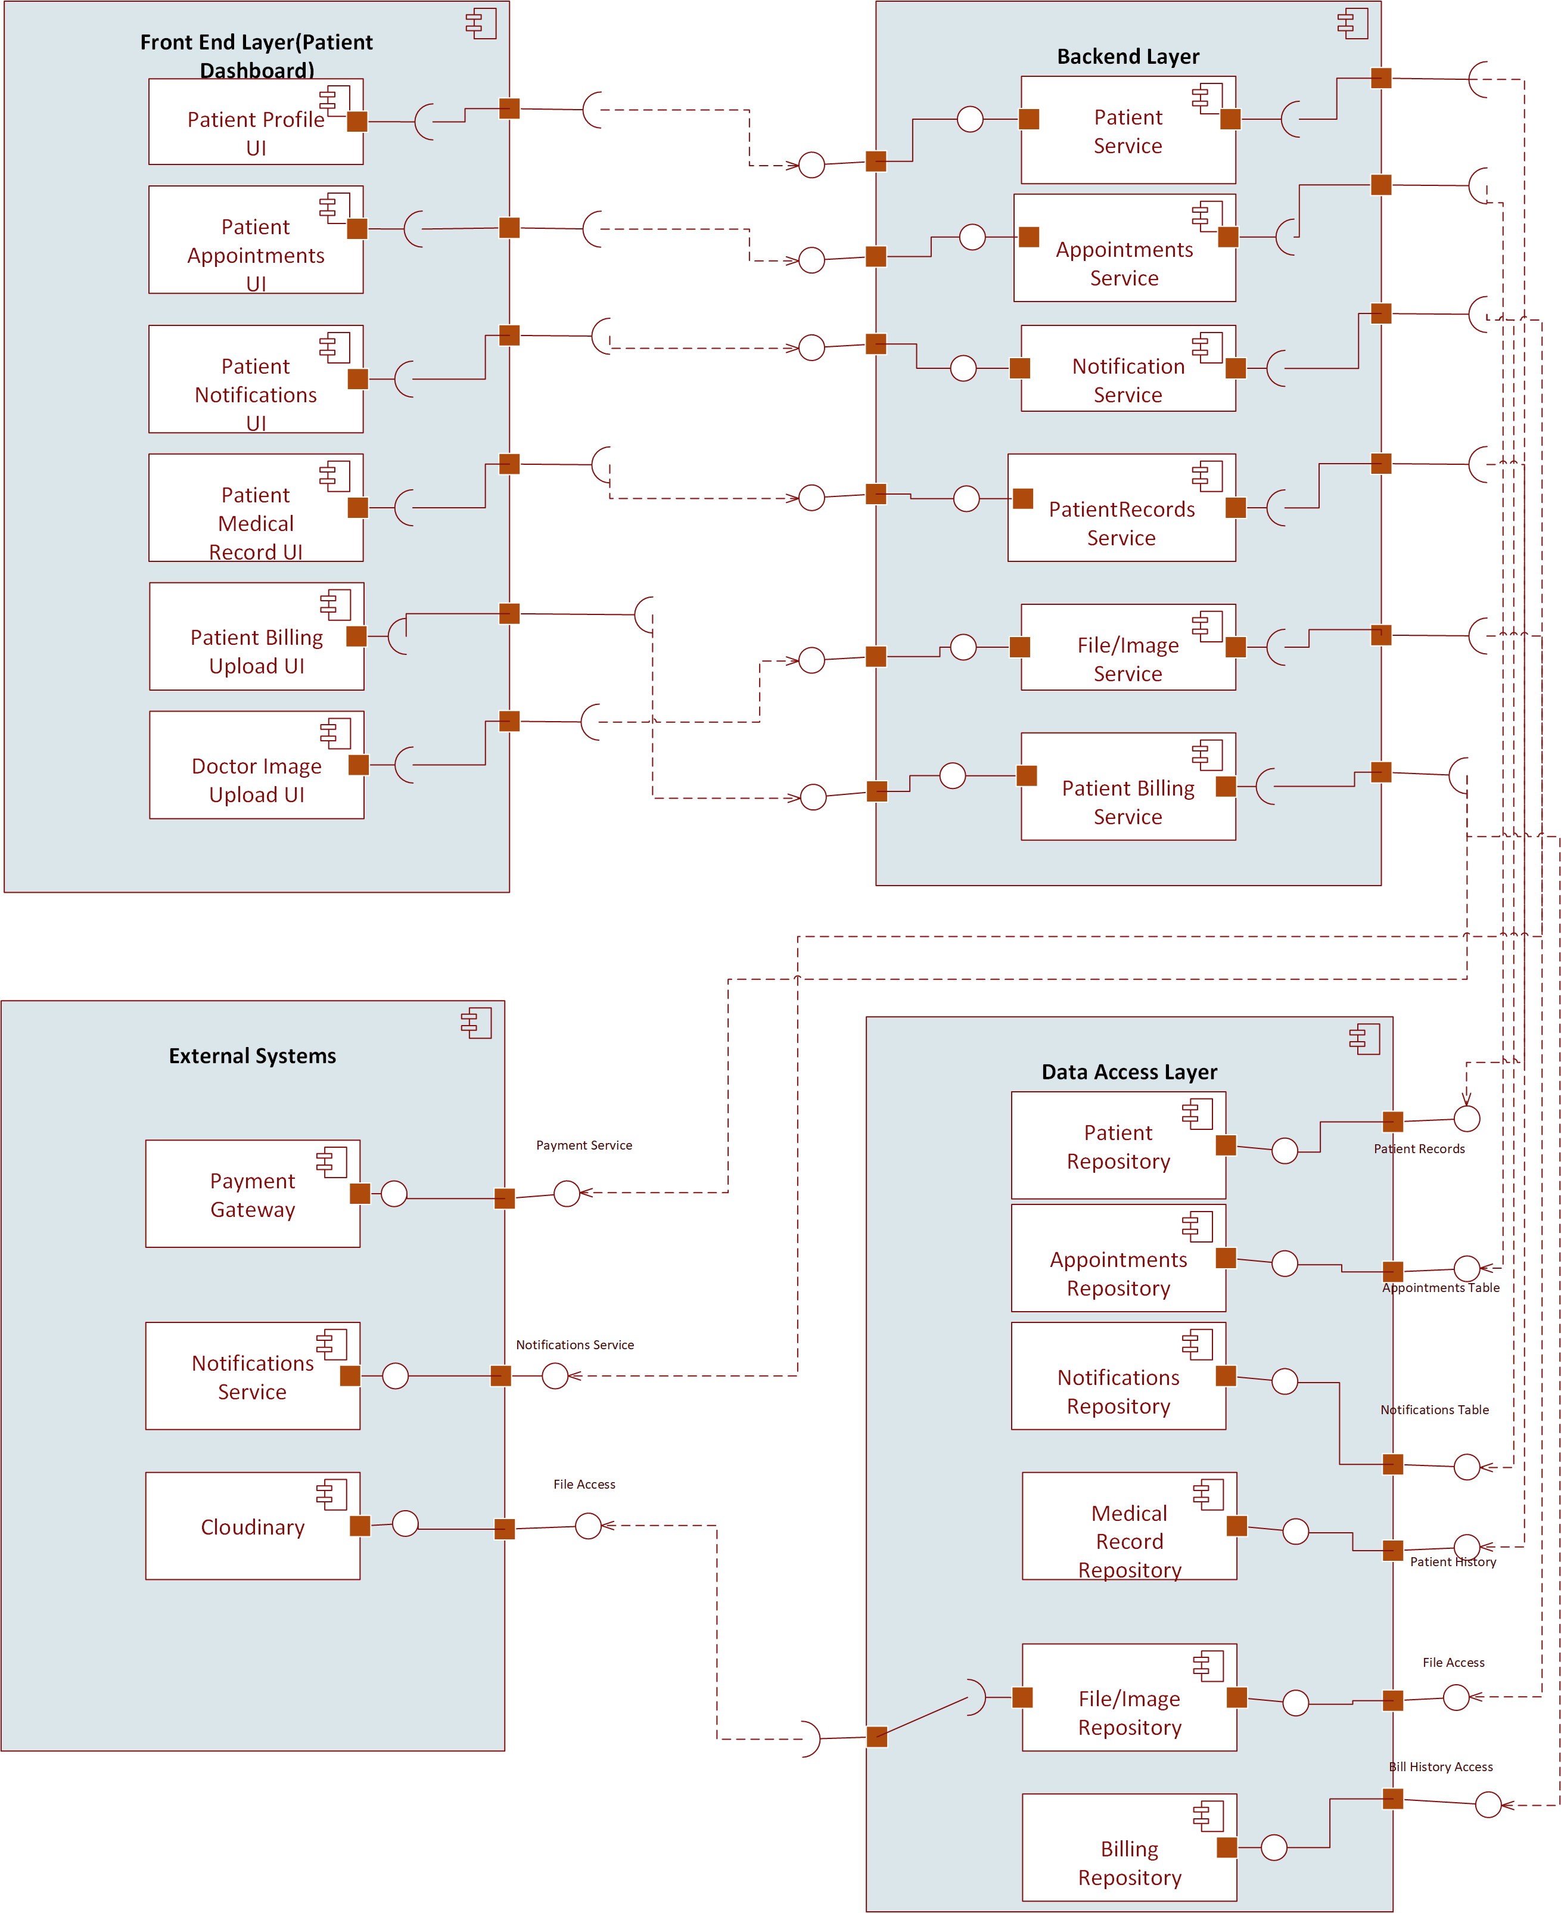

Figure 3.3.1 Patient Component Diagram

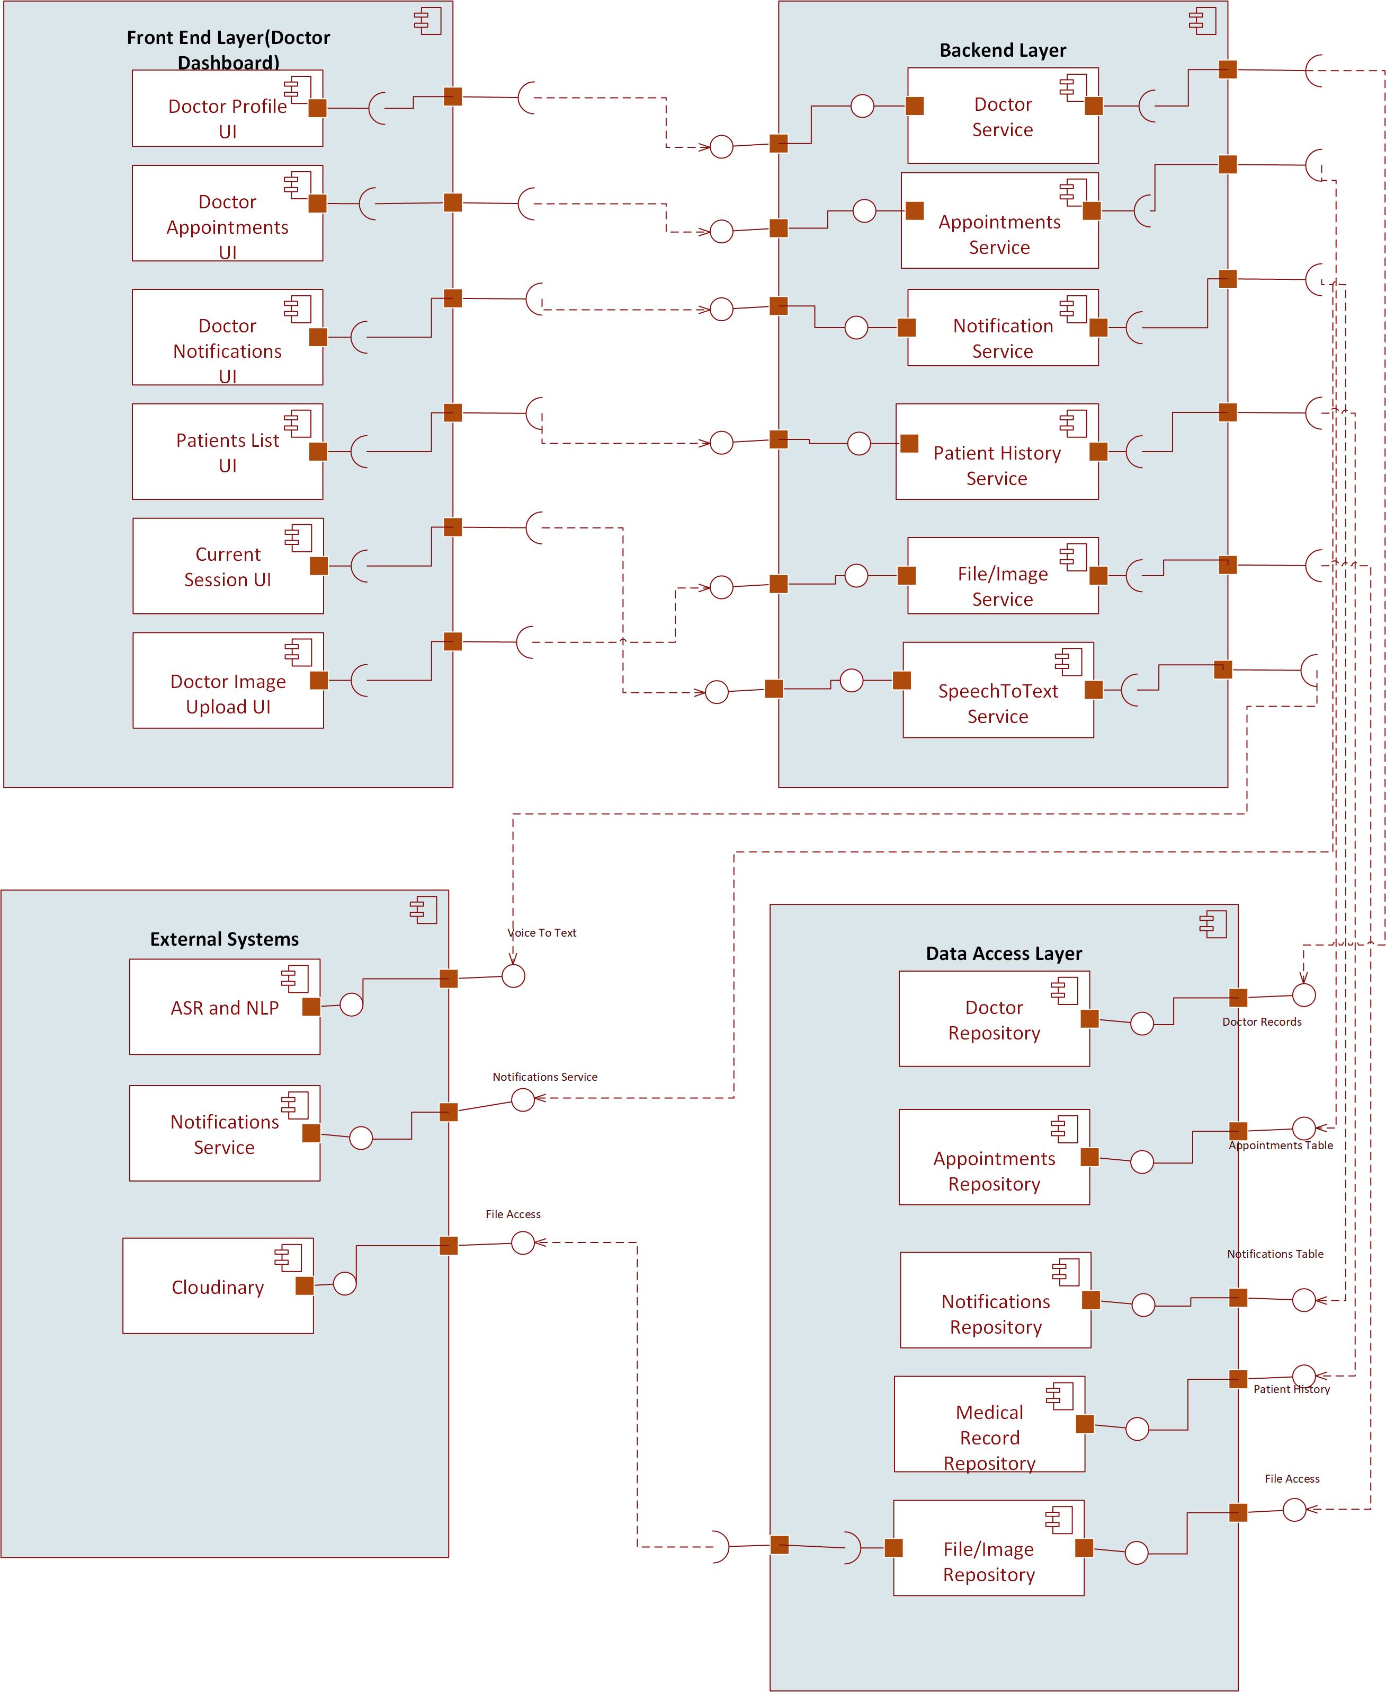

Figure 3.3.2 Doctor Component Diagram

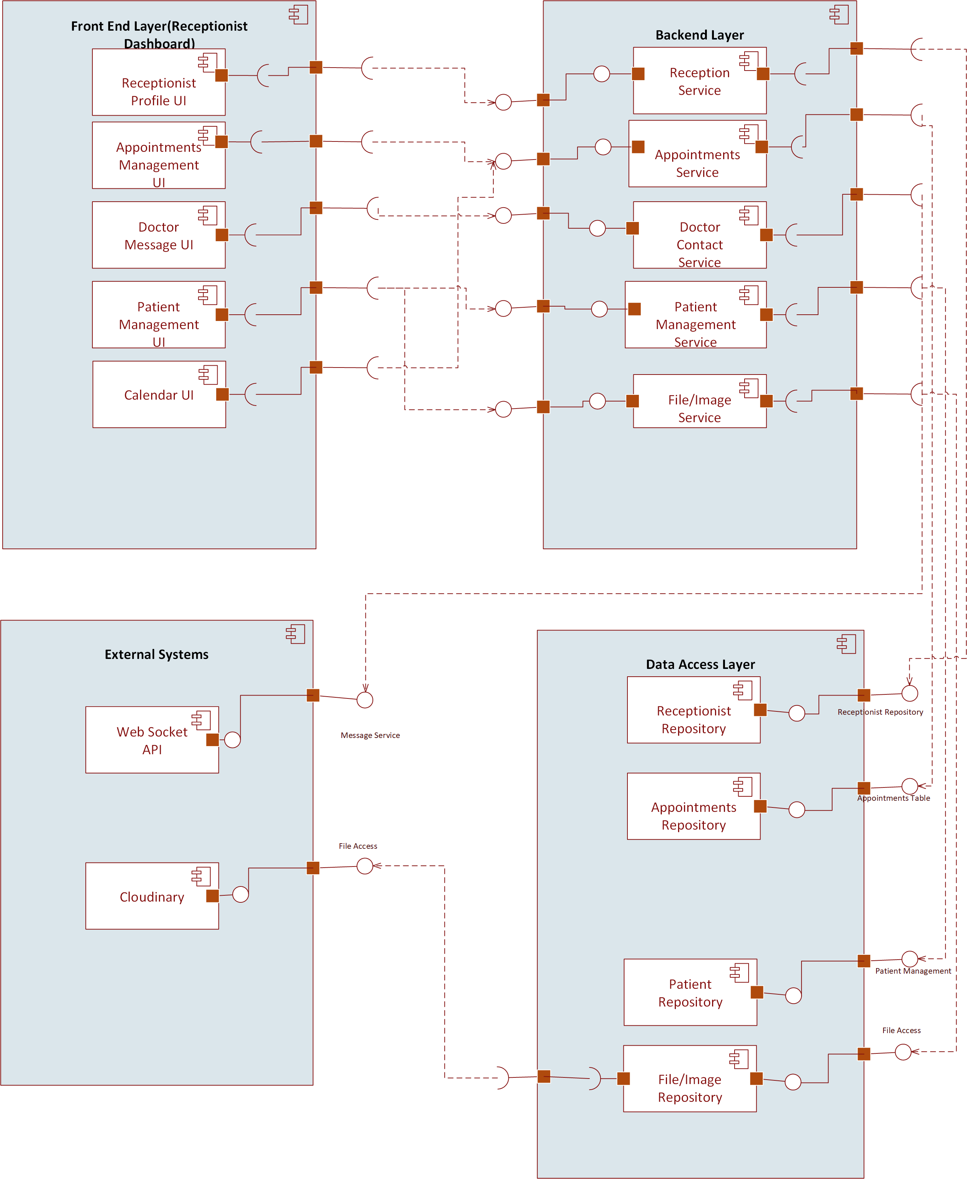

Figure 3.3.3 Receptionist Component Diagram

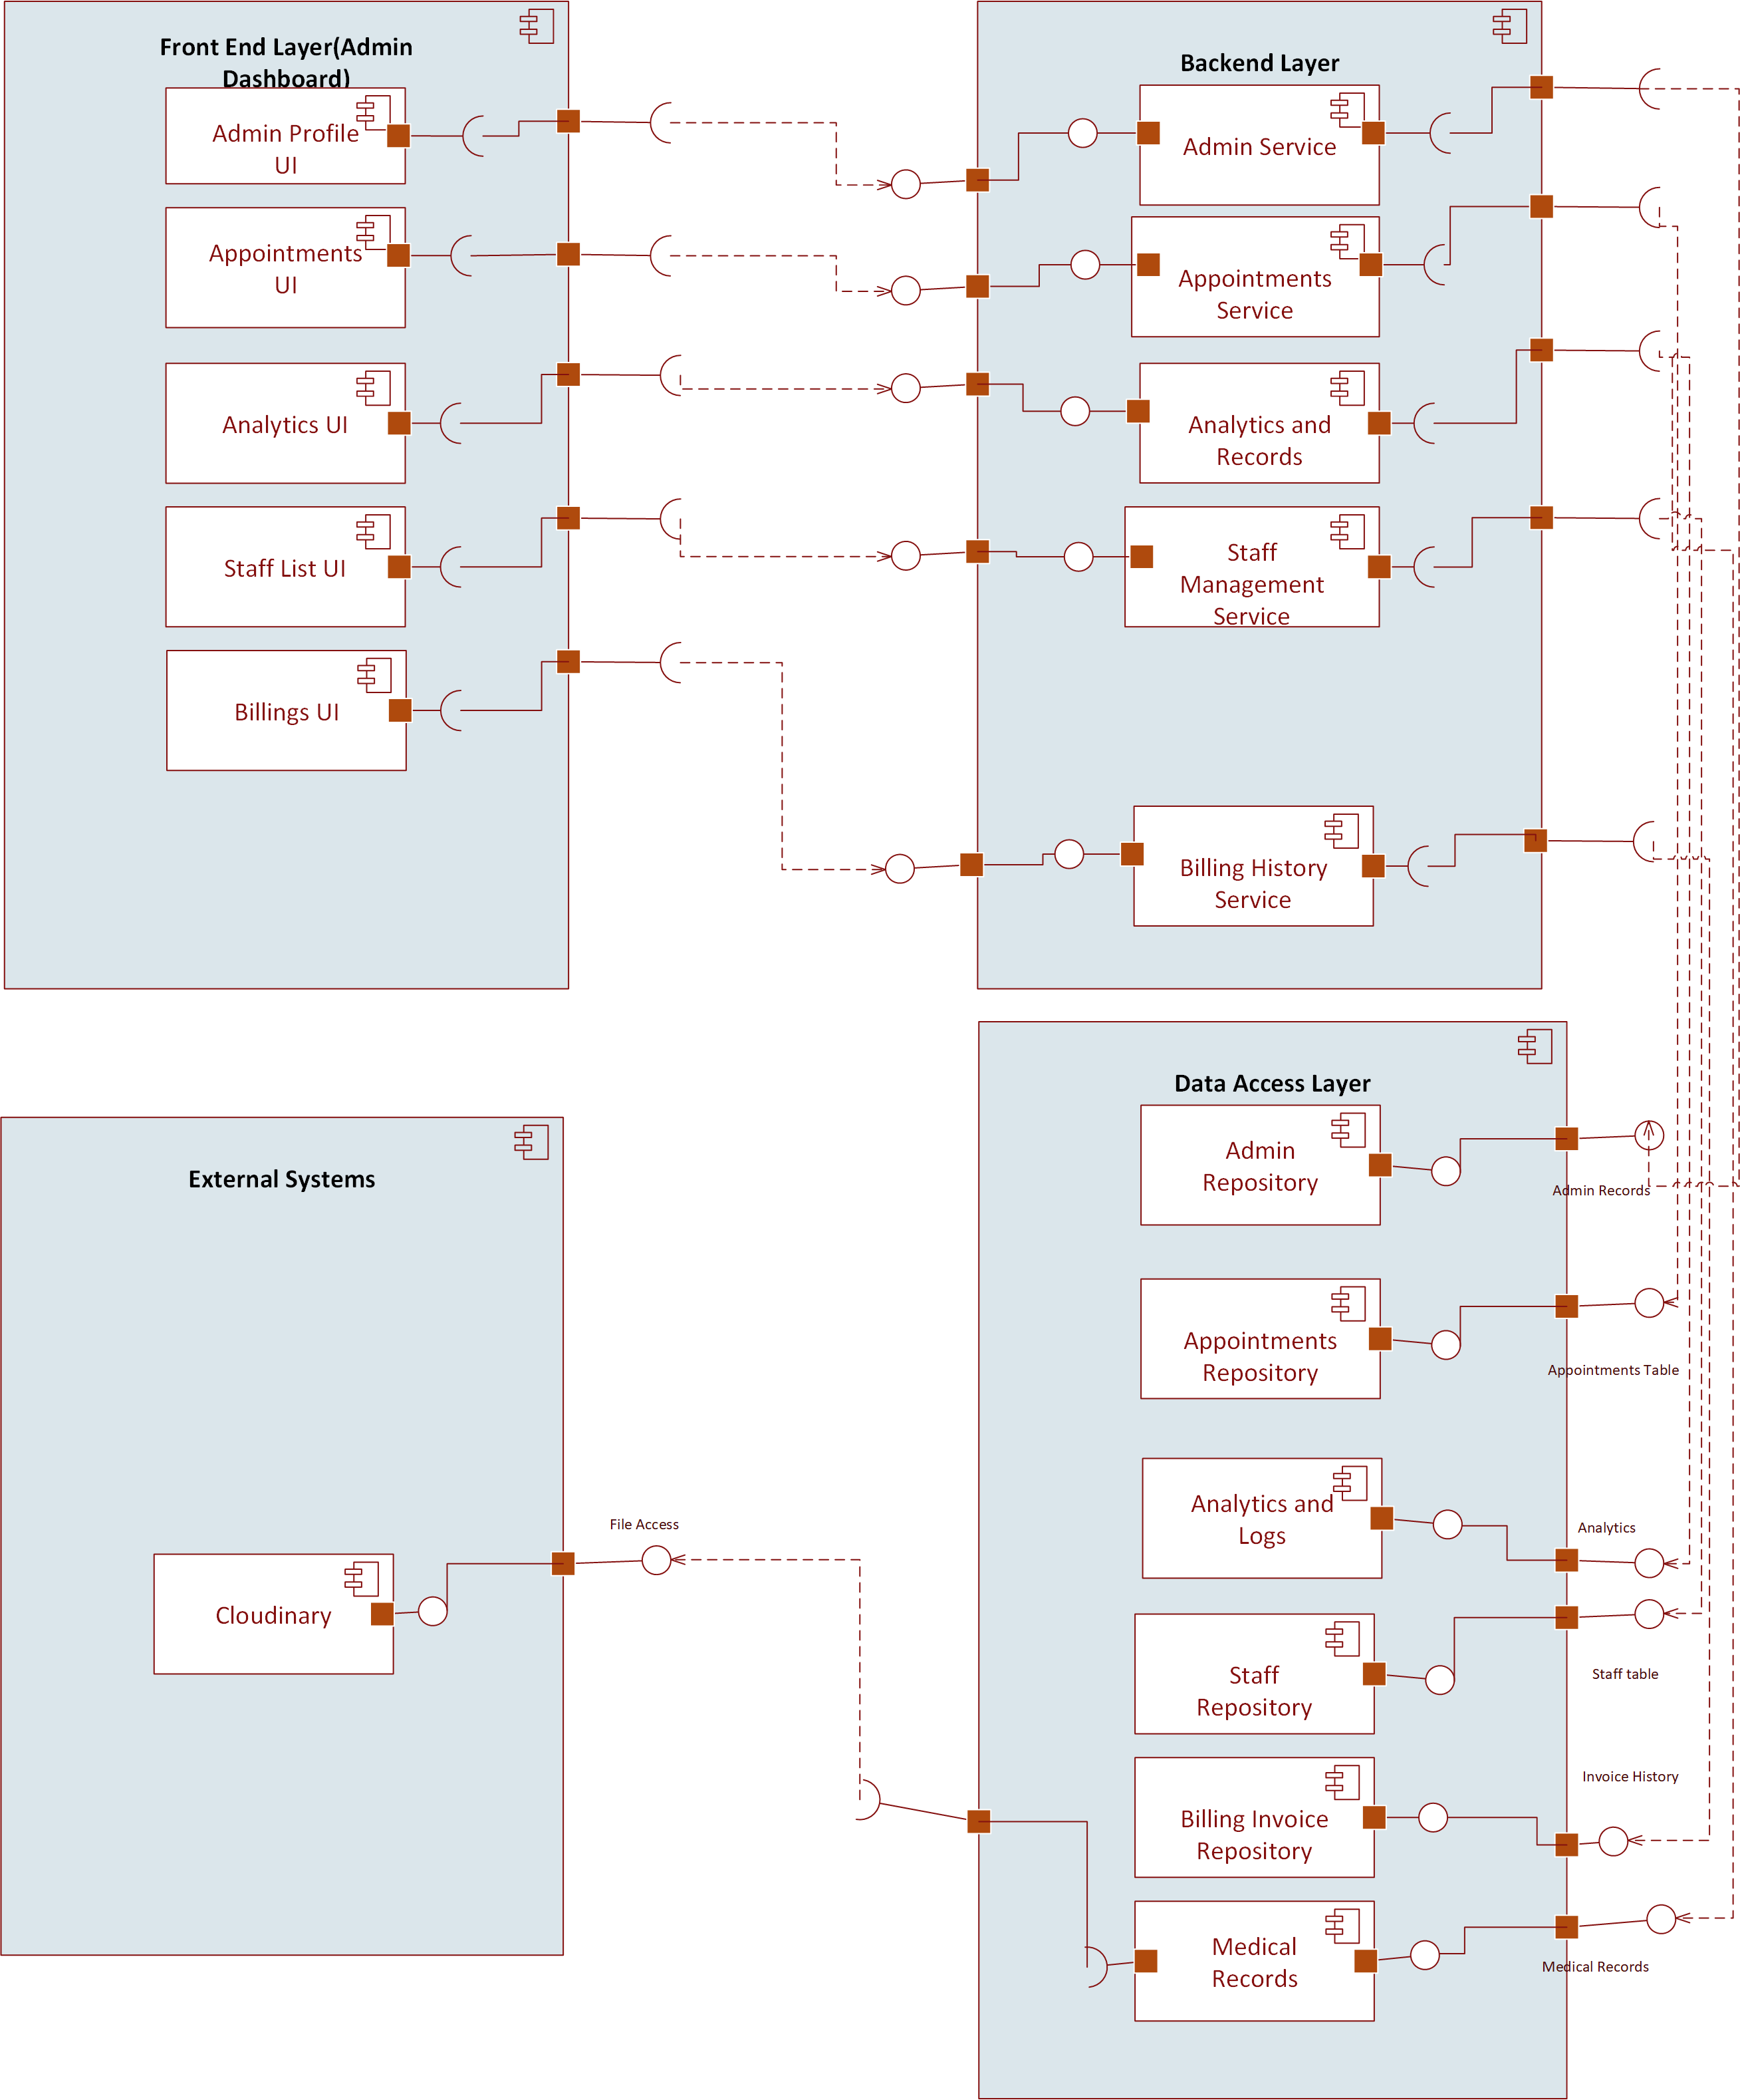

Figure 3.3.4 Admin Component Diagram

Design Strategies

4.1 Strategy 1: Modular Layered Architecture
The system is structured into logical layers:
- Presentation Layer (Frontend UI)
Patient portal, doctor portal, receptionist portal and admin dashboards.
- Application Layer (Backend Logic)
Appointment handling, patient record management, report processing, ASR pipelines.
- Data Access Layer
Repository classes, ORM queries, database communication.
- Database Layer
PostgreSQL for structured hospital data.

Reasoning
- Separates UI, business logic, and database interaction.
- Makes each module easy to modify or extend.
- Reduces complexity and avoids tangled dependencies.

Trade-offs
- Requires discipline to maintain layer boundaries.
- Slight overhead in communication between layers.
If the hospital later introduces pharmacy, lab integration, or insurance, new modules plug into the architecture without affecting existing ones.

4.2 Strategy 2: API-Driven / Service-Oriented Design
All modules communicate using clearly defined REST APIs.
Examples:
- /appointments/book
- /patients/update-history

Reasoning
- Clean separation between frontend and backend.
- Easy to integrate with mobile apps, external labs, or third-party hospital devices.
- Allows independent scaling of services later.

Trade-offs
- More API design work initially.
- Network latency between services.
The voice-to-text ASR service can run separately without modifying the main backend. This makes the system future-proof for new AI modules.

4.3 Strategy 3: Future System Extension & Plug-in Architecture
The architecture is designed to allow new workflows and modules without rewriting existing ones. Strategies used:
- Interface-based design
- Configurable modules
- Separate routing for each domain (patients, appointments, diagnosis, reports)

Reasoning
Hospitals frequently add:
- New lab machines
- New departments
- New data flows (insurance, pharmacy automation)

Trade-offs
- Requires abstraction and planning during early design.
- Some modules might have more configuration overhead.
If we add a Radiology module, it simply becomes:
- New routes: /radiology/upload, /radiology/report
- New table: radiology_reports
- No impact on appointments, patients, or ASR pipeline.

4.4 Strategy 4: Unified Data Management Strategy
The system uses a consistent approach to data storage:
- PostgreSQL for structured hospital records
- Cloud storage for files (images)
- ACID transactions for sensitive updates
- Foreign keys to prevent inconsistent data
- Indexed queries for real-time performance (appointments, patient history)

Reasoning
- Ensures correctness, especially for medical data.
- Enables fast retrieval of patient histories.
- Supports large-scale hospital operations.

Trade-offs
- Requires schema planning.
- Some features (e.g., full-text search) need extra tools.
Appointment booking uses transactions to prevent double-booking when multiple receptionists try to schedule the same slot at the same time.

4.5 Strategy 5: Concurrency & Synchronization Controls
Some hospital actions need safe handling of parallel requests:
- Appointment booking
- Prescription updates
- Audio file uploads → ASR processing
- Simultaneous doctor and admin updates on patient record
Concurrency mechanisms used:
- Database locks
- Transaction isolation
- Atomic operations
- Queues for long tasks (ASR, NLP)

Reasoning
- Guarantees consistent data.
- Prevents race conditions.
- Critical for time-sensitive medical operations.

Trade-offs
- High concurrency may reduce performance due to locking.
- Requires careful backend design.
When two receptionists book the same doctor slot:
- Backend locks the slot record
- Checks availability
- Inserts appointment only if slot is free
- Releases the lock
This ensures only one booking is stored.

4.6 Strategy 6: Reusability of Components
Common utilities are designed for reuse across modules:
- Logging service
- Authentication middleware
- File upload utility
- Notification/email service
- Validation helpers

Reasoning
- Reduces repeated code.
- Makes maintenance easier.
- Ensures consistent behavior across modules.

Trade-offs
- Shared services must be carefully versioned to avoid breaking modules.
The file upload service (used by voice recordings and lab reports) is a single shared component used by multiple modules.

4.7 Strategy 7: Secure-by-Design Architecture
Security is built into the architecture instead of added later:
- Role-based access control (Admin, Doctor, Patient)
- Encrypted communication (HTTPS)
- Input validation
- Audit logging
- Secure authentication tokens

Reasoning
Hospitals handle extremely sensitive patient data.

Trade-offs
- Adds development overhead
- Requires periodic updates and policy checks
Doctors can only access their assigned patient records. Patients cannot view internal notes or doctor comments.

Detailed System Design

  - Class Diagram

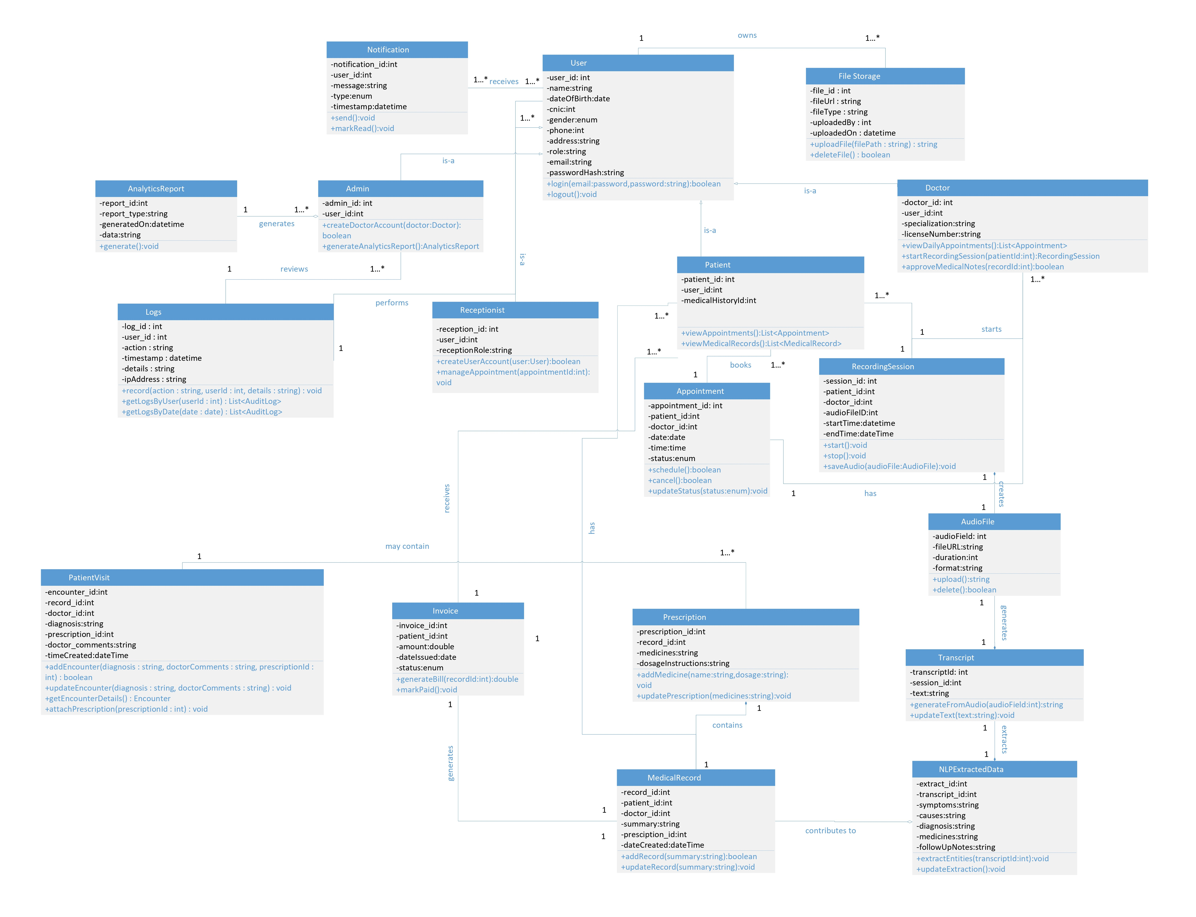
Figure 5.1 Class Diagram

  - ER Diagram

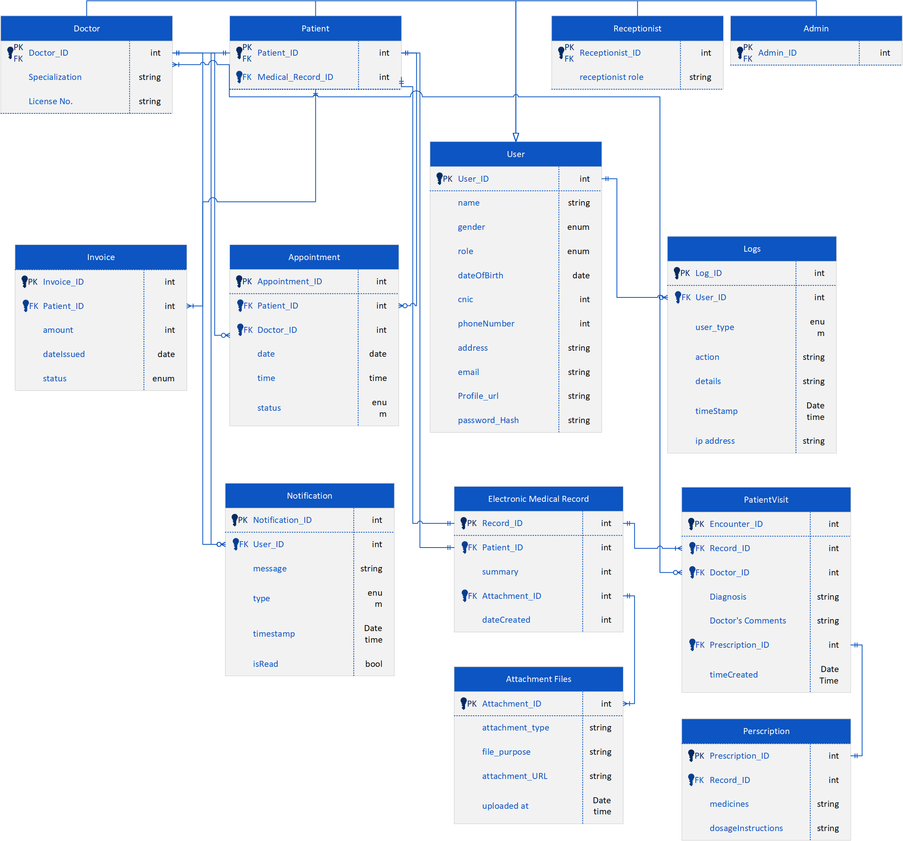

Figure 5.2 ER Diagram

  - State Transition Diagram

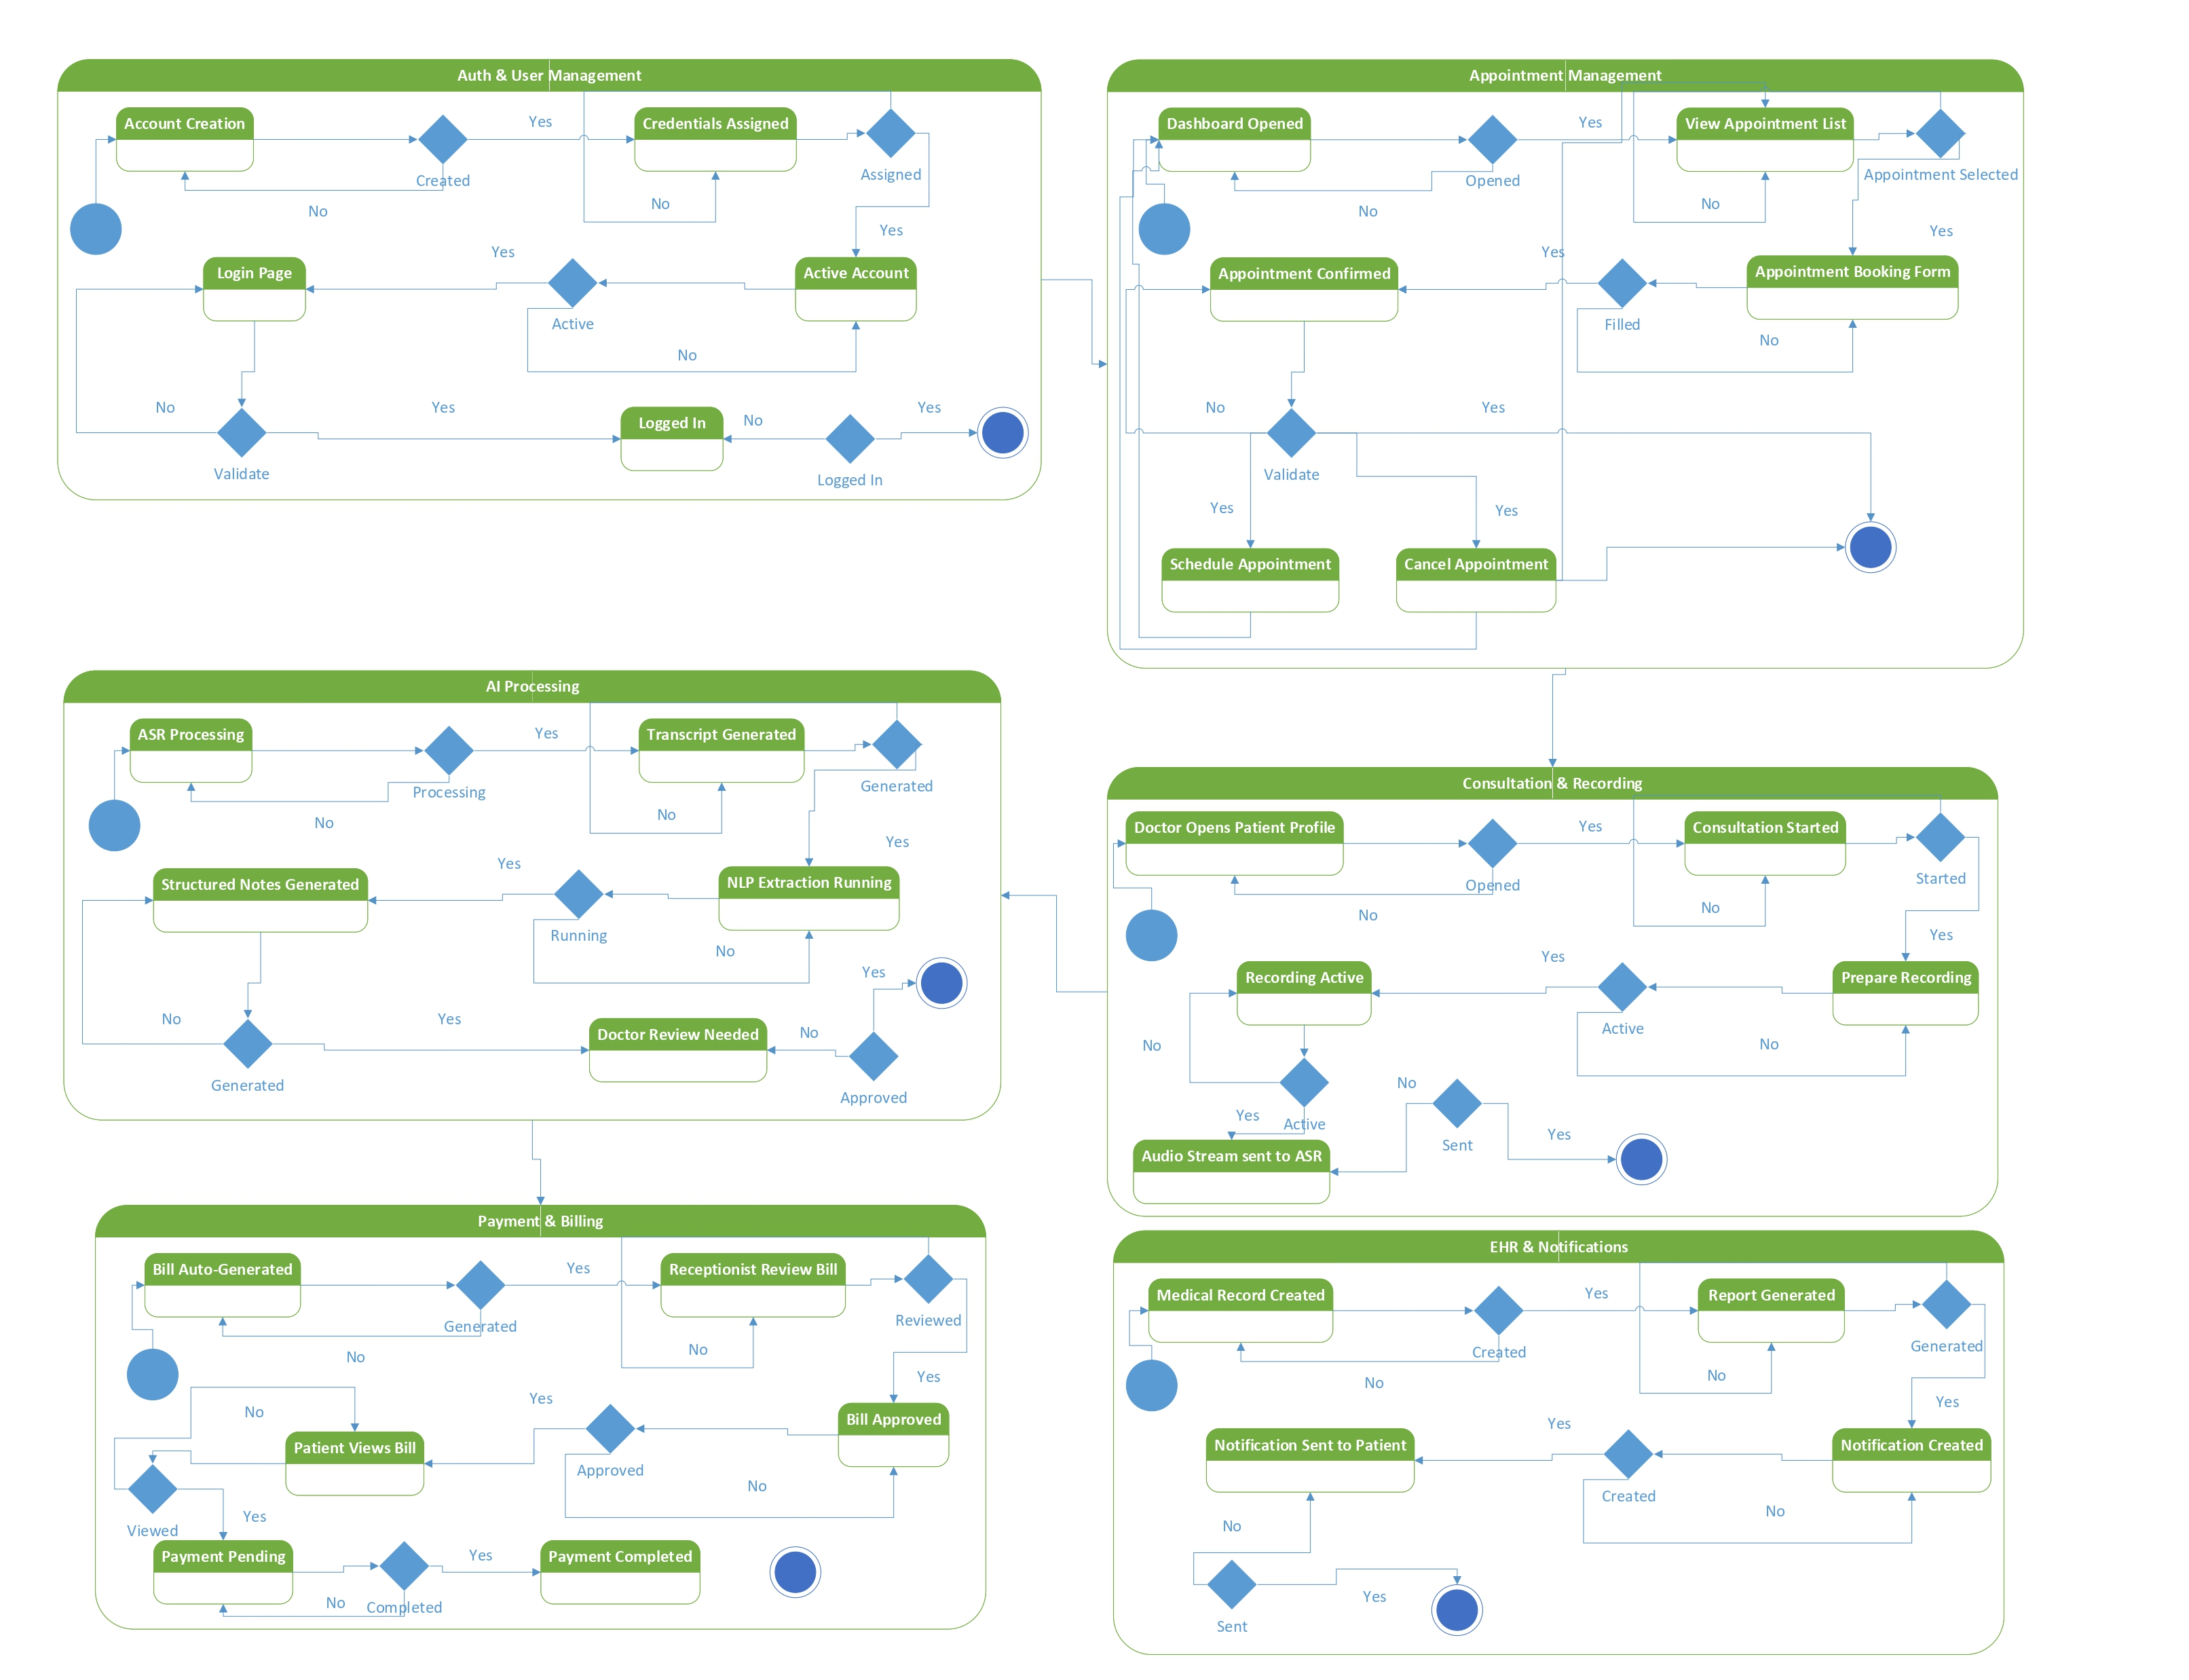
Figure 5.3 State Transition Diagram

  - Sequence Diagram

    - Sequence Diagram (Login)

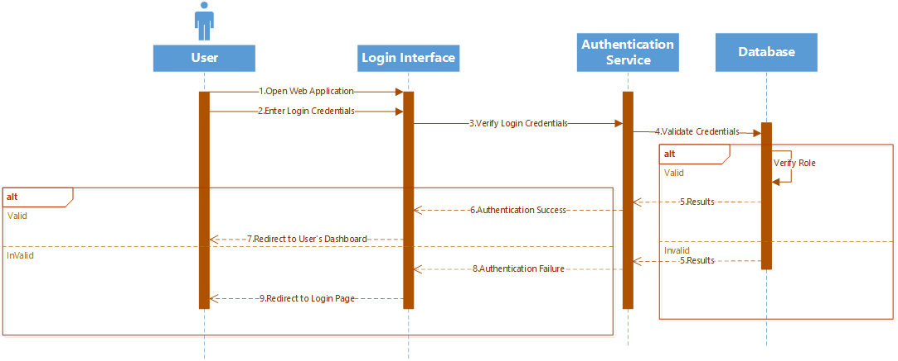
Figure 5.4.1 Sequence Diagram (Login)

    - Sequence Diagram (Patient)
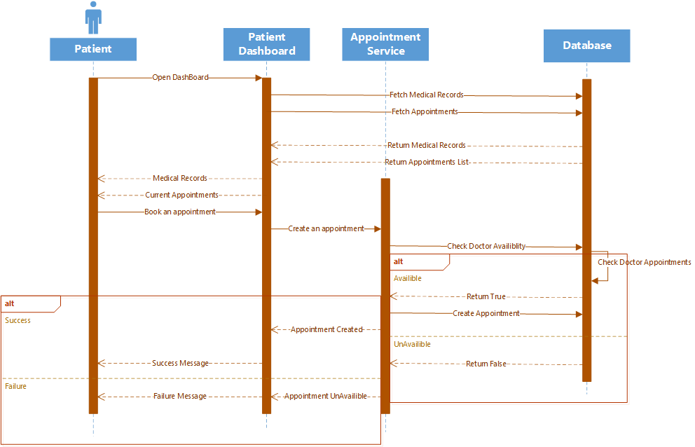
Figure 5.4.2 Sequence Diagram (Patient)

    - Sequence Diagram (Doctor)

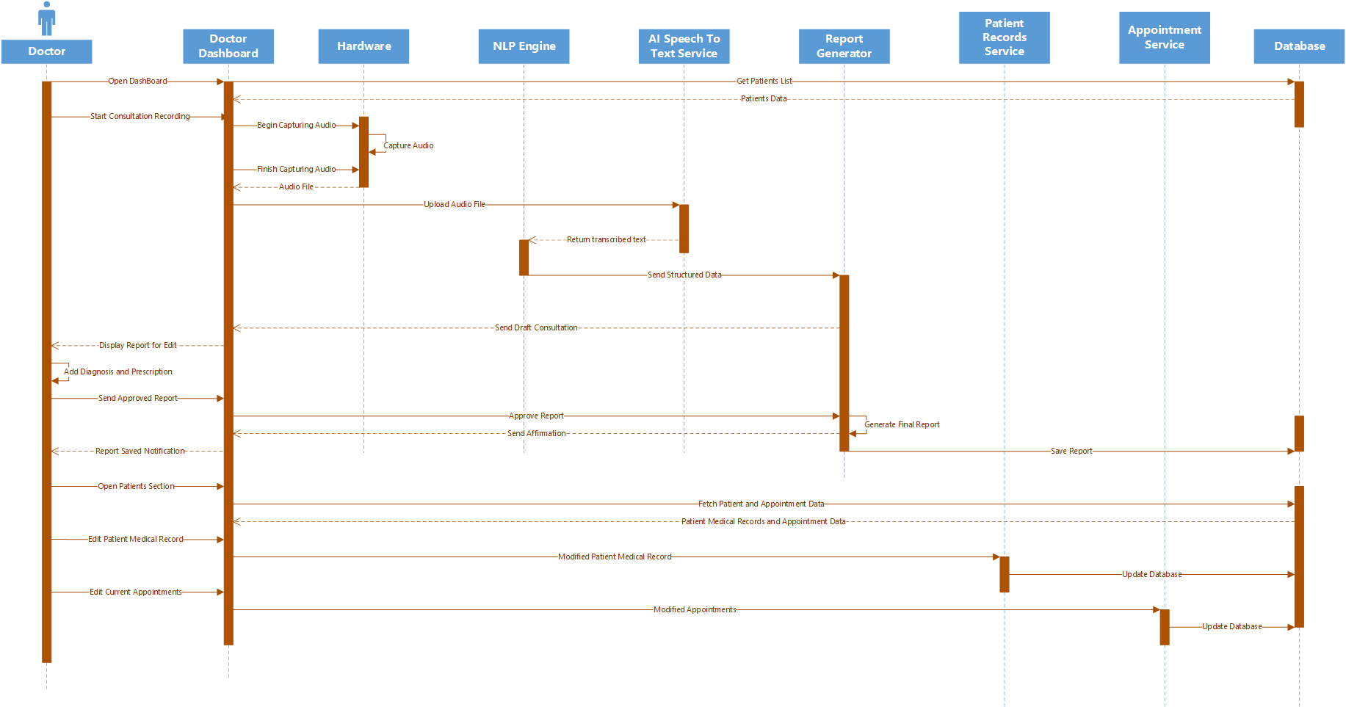
Figure 5.4.3 Sequence Diagram (Doctor)

    - Sequence Diagram (Receptionist)

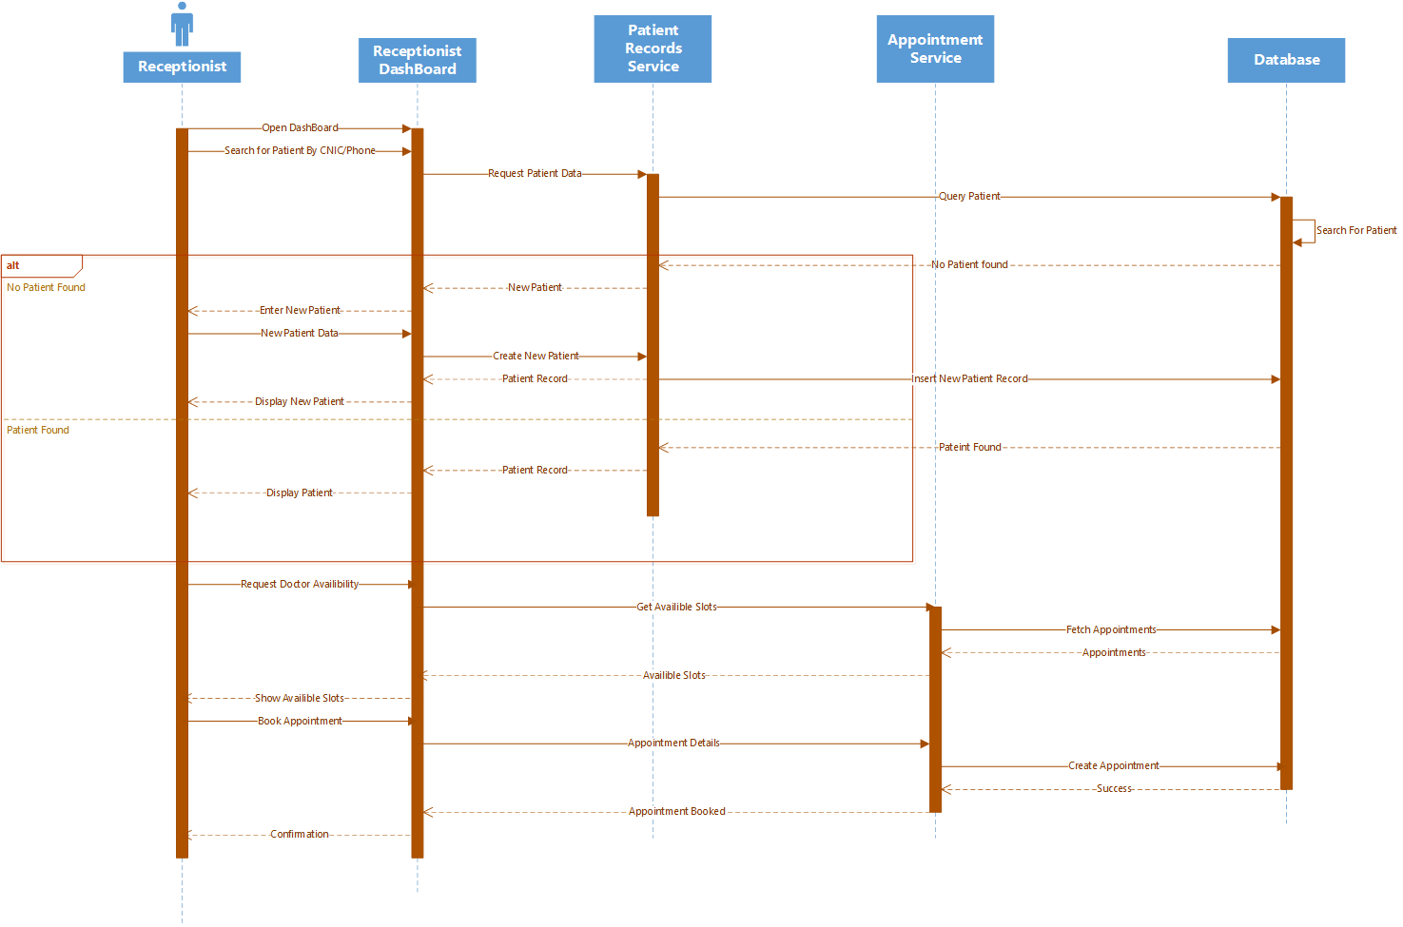
Figure 5.4.4 Sequence Diagram (Receptionist)

    - Sequence Diagram (Admin)

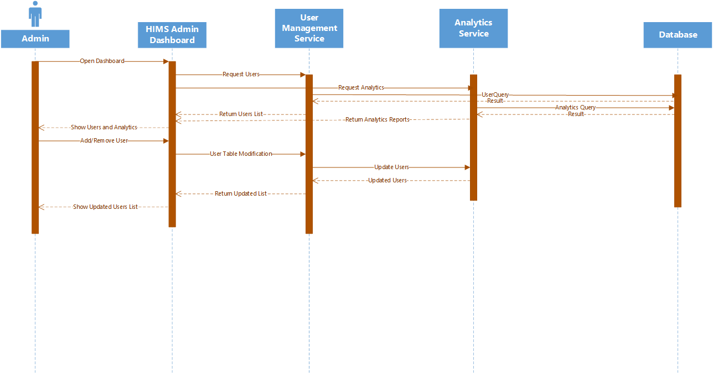
Figure 5.4.5 Sequence Diagram (Admin)

  - Data Flow Diagram

    - DFD Level 0

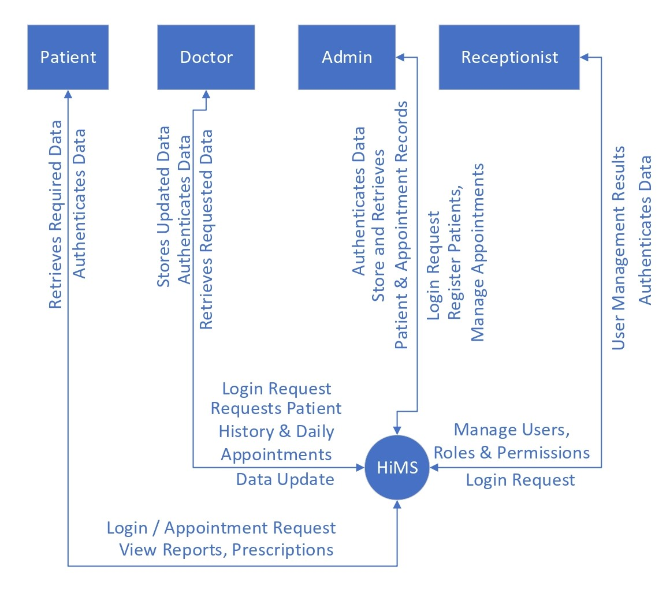
Figure 5.5.1 DFD Diagram (Level 0)

    - DFD Level 1

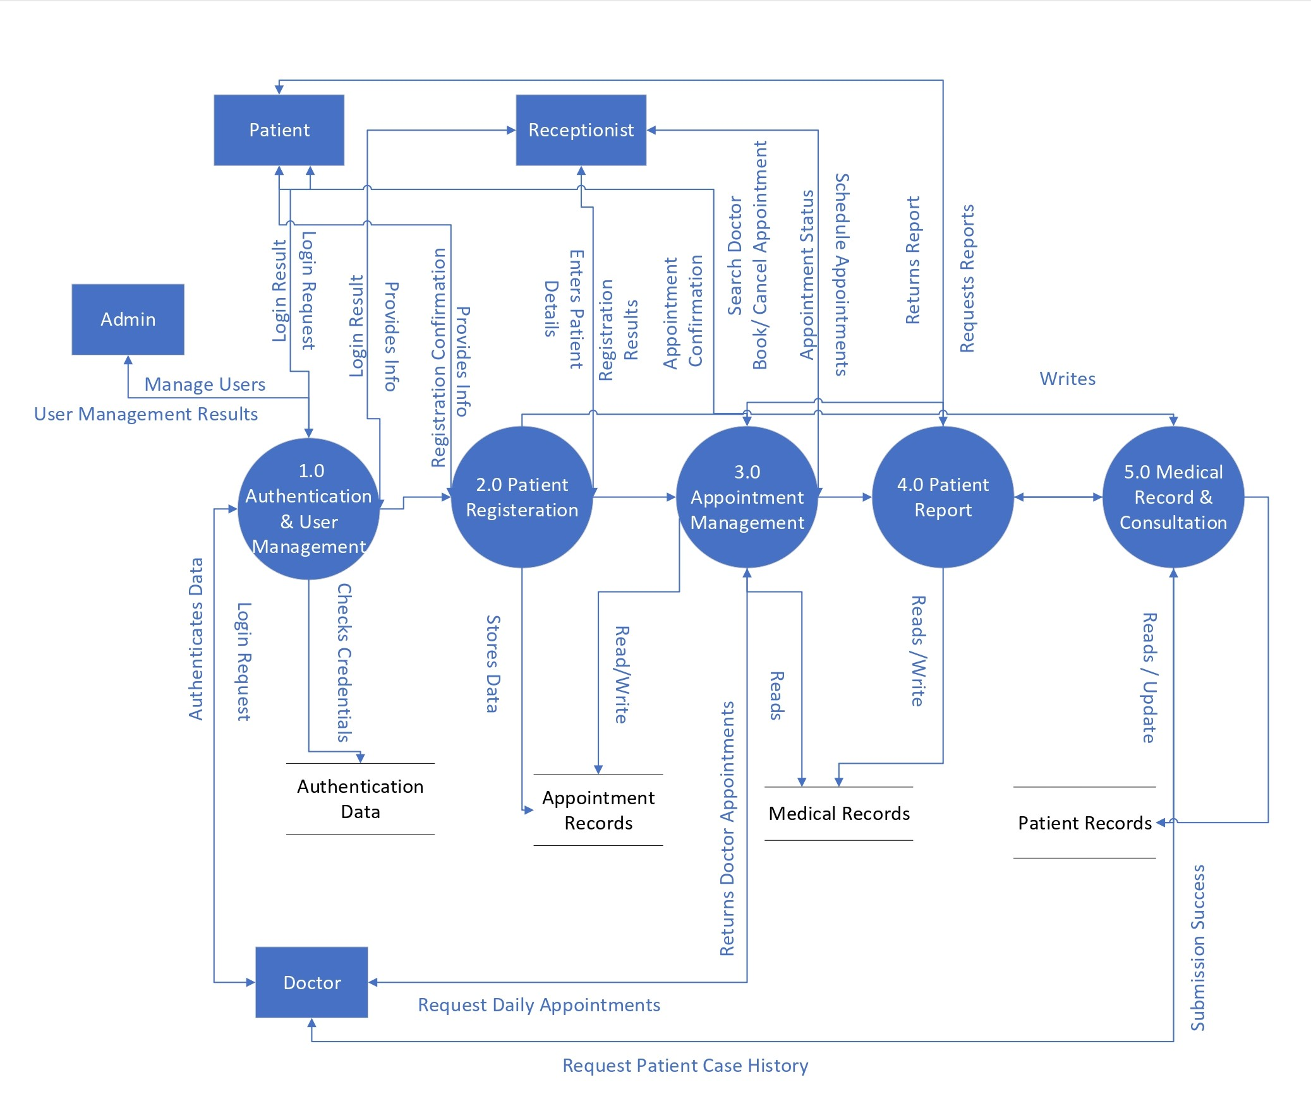
Figure 5.5.2 DFD Diagram (Level 1)
    - DFD Level 2

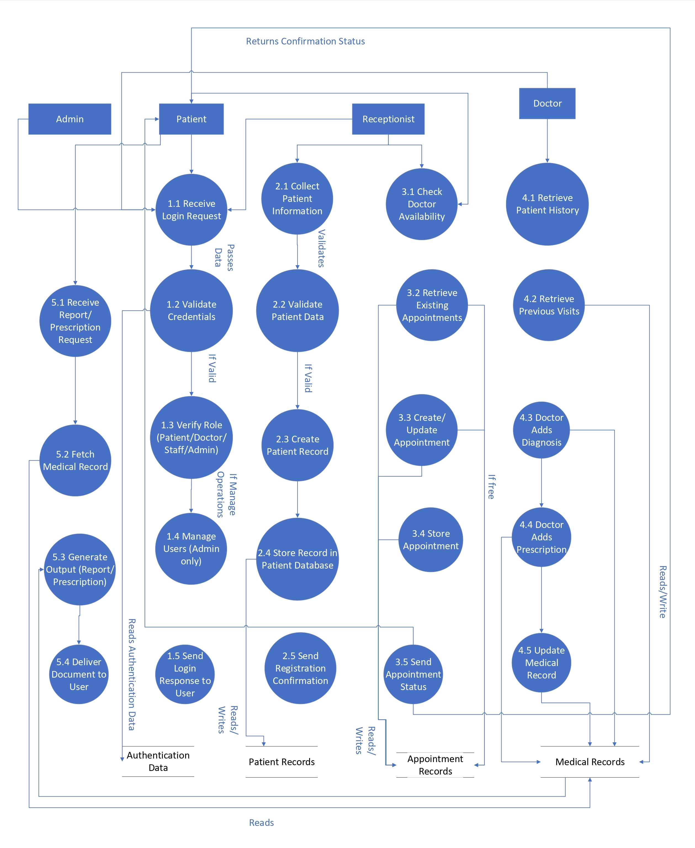
Figure 5.5.3 DFD Diagram (Level 2)

  - GUI

5.6.1 Landing Page

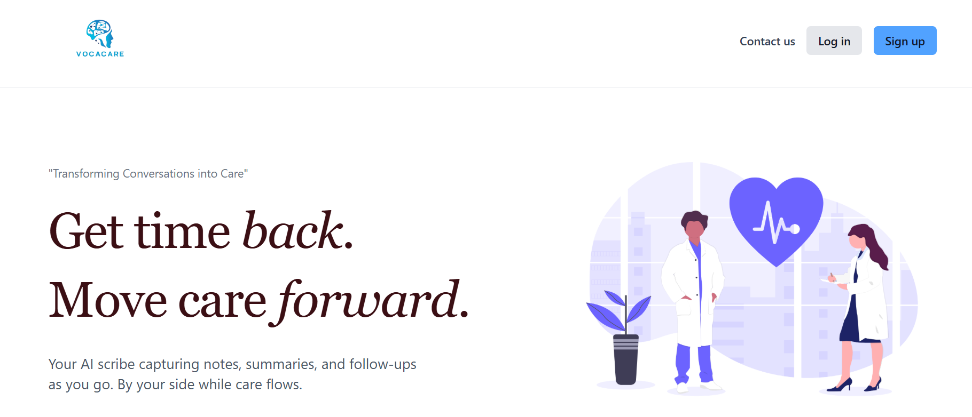

Purpose & Context:
- Entry point to the system for all user roles.
- Introduces the platform and leads users to login or signup.

Element Details:

1.Branding Area
- Vocacare logo
- Tagline: “Transforming conversations into care.”

2.Primary Actions
- Sign In Button → navigates to Sign in page.
- Log In Button → navigates to Login page.

User Flow (Landing Page)

1. User clicks “Sign In”
System Action:
- Redirects to Register Page.

2. User clicks “Log In”
System Action:
- Redirects to Login Page.

3. User returns to landing
System Action:
- No state stored; fresh page reload.

5.6.2 Register and Login Page

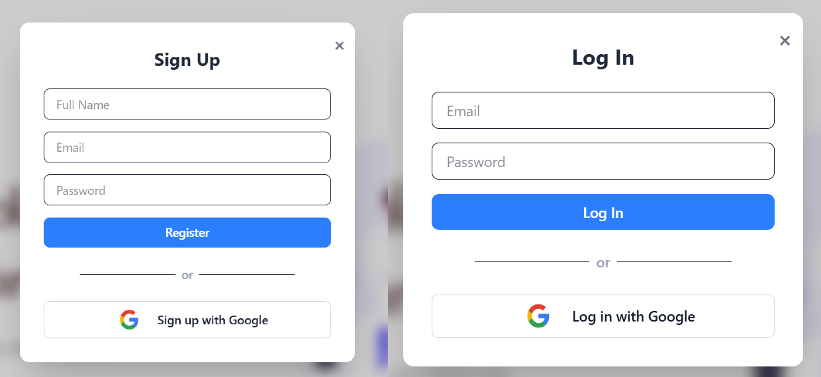

Purpose & Context
Secure access to the system for all roles.

Element Details

Login Form
- Email input
- Sign In button
- Error messages
- Log in with Google

Register Form
- Email input
- Name input
- Password input
  - Register Button

User Flow

1. Enter Email + Password → Click Sign In
System Actions:
- Validate email format
- Validate password length
- Send credentials to API
- If valid → redirect to relevant dashboard
- If invalid → show inline error: “Incorrect email or password.”

2. Enter Name+ Email + Password → Click Register
System Actions:
- Validate email format
- Validate password length
- Send credentials to API
- If valid → redirect to relevant dashboard
- If invalid → show inline error: “Invalid email or password.”

5.6.3 Patient Dashboard

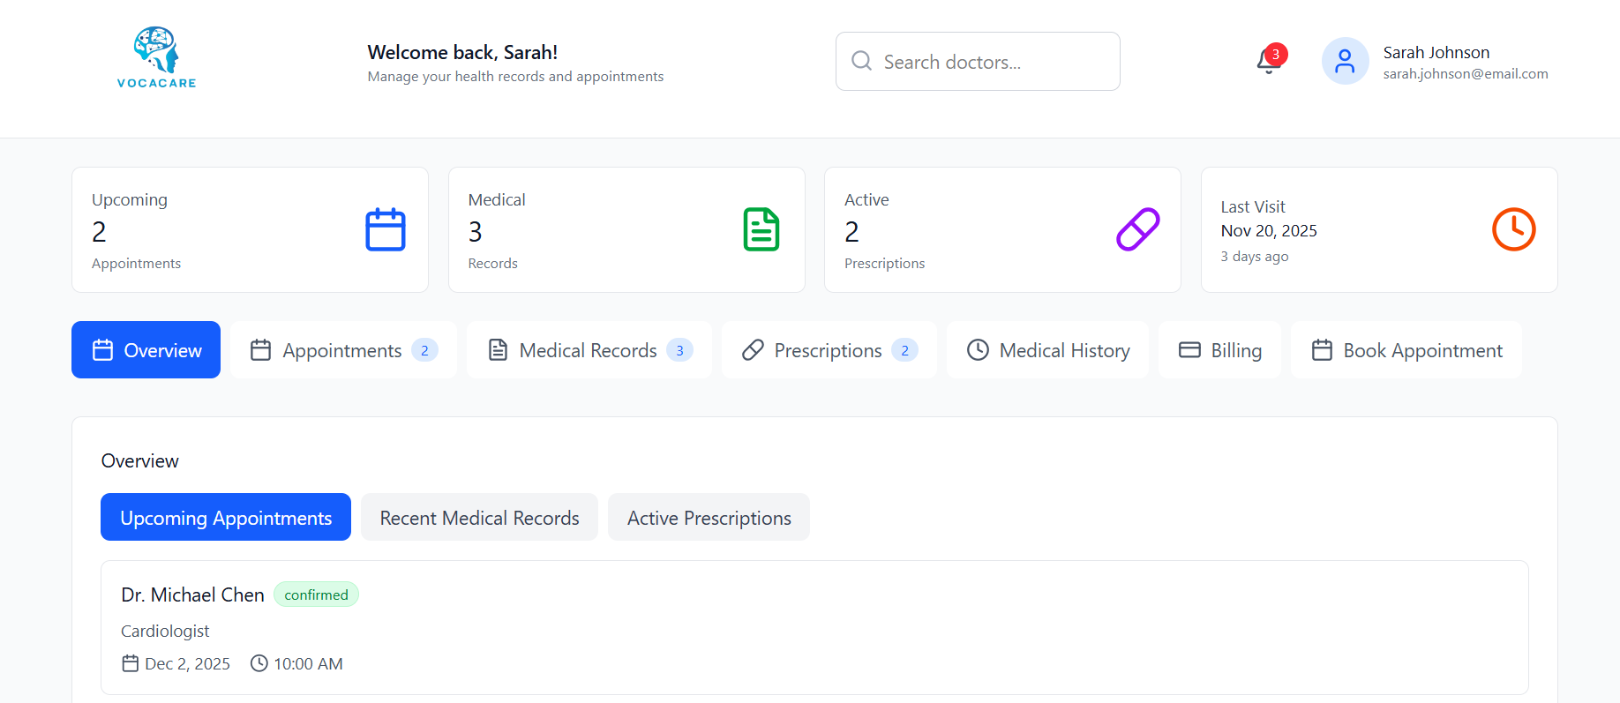

Purpose & Context
Allow patients to manage bookings, medical records, prescriptions, invoices.

Element Details

Header
- Logo
- Welcome
- Search
- Notifications
- User profile

Modules
- Upcoming Appointments
- Medical History
- Prescriptions
- Billing Summary
- Quick Actions

User Flow

1. Patient books an appointment
System Action:
- Opens calendar
- Select doctor, date, time
- Confirm
- Appointment appears in dashboard

2. Patient views medical history
System Action:
- Load personal medical timeline
- Click entry → opens details

3. Patient pays invoice
System Action:
- Redirect to billing
- Choose payment method
- Confirm payments

4. Patient clicks notification bell
System Action:
- Dropdown opens
- Notifications marked as read when viewed

5. Patient edits profile
System Action:
- Update profile
- Save and refresh

5.6.4 Receptionist Dashboard

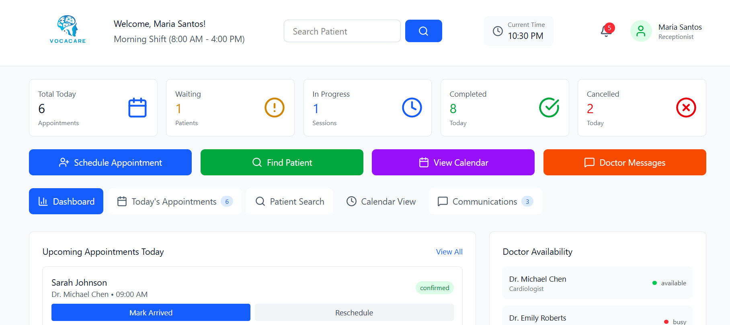

Purpose & Context
Manage patients, check-ins, appointments, scheduling, reception workflow.

Element Details

Header
- Logo
- Welcome section
- Search patients
- Current time display
- Notifications dropdown
- User menu (profile, settings, logout)

Main Modules
- Today’s appointments
- Patient search
- Quick actions (Register patient, Book appointment)
- Appointment overview tables

User Flow

1. Receptionist searches for a patient
System Action:
- Query patients
- Show list of matches
- Click result → open patient profile

2. Receptionist clicks “Check-In”
System Action:
- Mark appointment as “Arrived”
- Update doctor’s appointment list
- Toast: “Patient checked in.”

3. Click “Book Appointment”
System Action:
- Redirect to appointment form
- Pre-fill patient info if patient was selected

4. Clicking Notifications Icon
System Action:
- Dropdown opens
- Mark notifications as read when viewed

5. Clicking User Profile
System Action:
- Show menu options
- Selecting logout → return to login

5.6.5 Doctor Dashboard

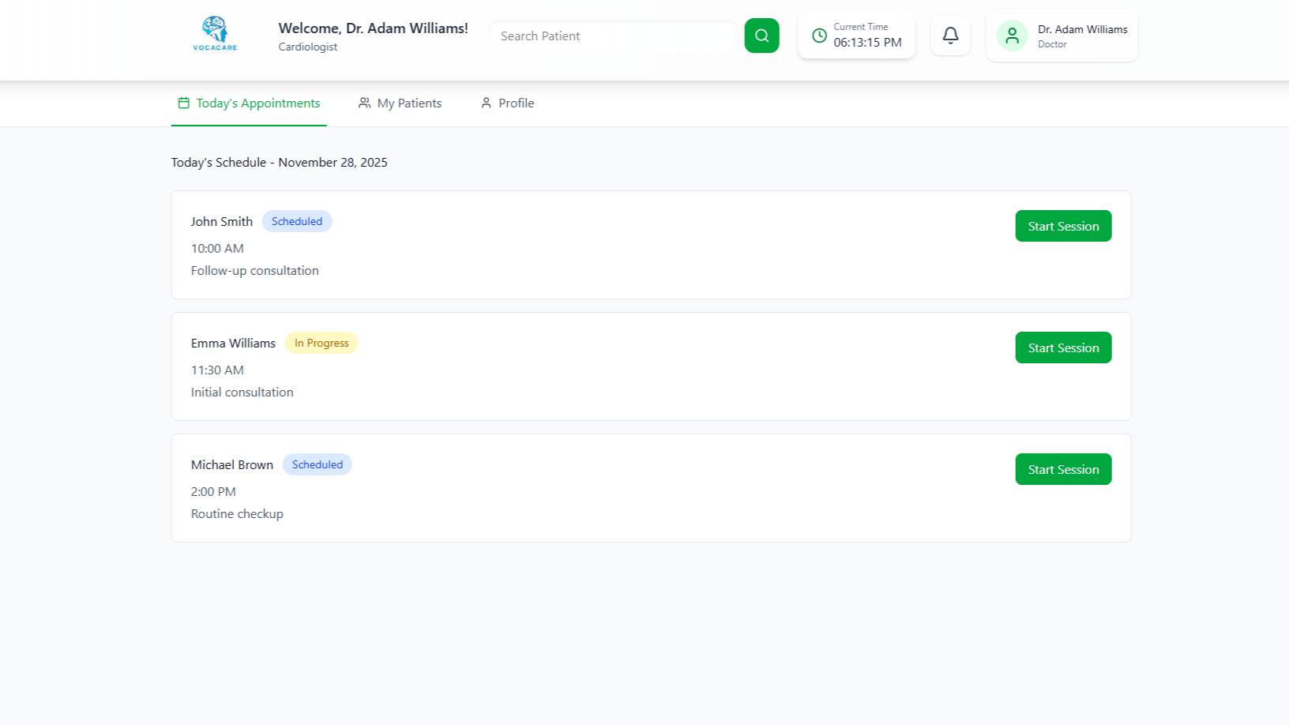
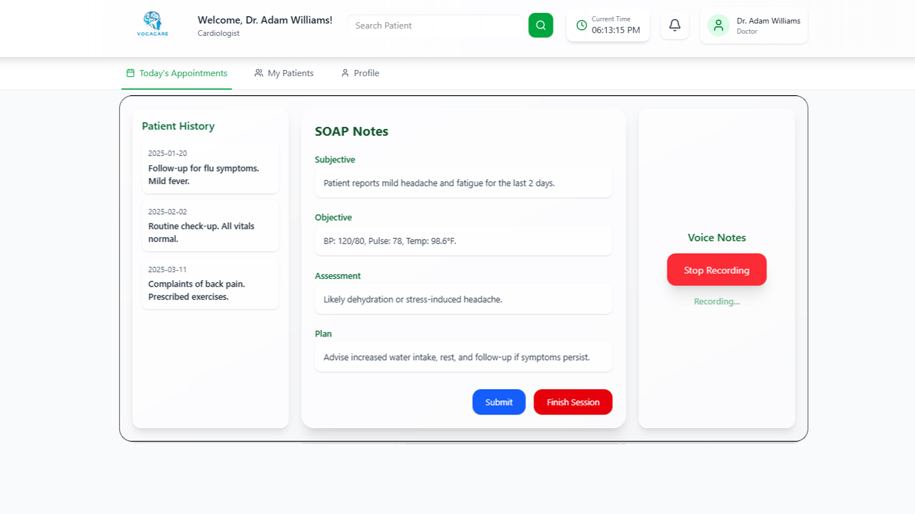

Purpose & Context
Daily workflow for doctors: appointments, patients, medical history, SOAP sessions.

Element Details

Header
- Logo + welcome
- Search patients
- Current time
- Notifications
- User menu

Tabs
- Today’s Appointments
- My Patients
- Profile

Session Modal
- Left: Patient history
- Center: SOAP notes
- Right: Voice recorder
- Submit + Finish Session

User Flow

1. Doctor clicks “Start Session”
System Action:
- Opens fullscreen
- Loads patient history + SOAP template
- Initializes microphone permissions (if allowed)

2. Doctor edits SOAP Notes
System Action:
- Auto-save draft locally
- Highlight unsaved changes

3. Doctor clicks “Start Recording”
System Action:
- Ask for mic permission
- Begin audio capture
- Display “Recording…” pulse state

4. Doctor clicks “Stop Recording”
System Action:
- Save audio blob
- Display playback option (optional)

5. Doctor clicks “Submit”
System Action:
- Validate SOAP fields
- Upload notes + audio
- Close modal + mark appointment as “Completed”
- Toast: “Session Submitted.”

6. Doctor clicks “Finish Session”
System Action:
- Close modal
- Return to appointments tab

7. Doctor searches for a patient
System Action:
- Trigger global search
- Clicking a patient opens detailed profile

8. Editing profile
System Action:
- Save doctor info
- Refresh UI

5.6.6 Admin Dashboard
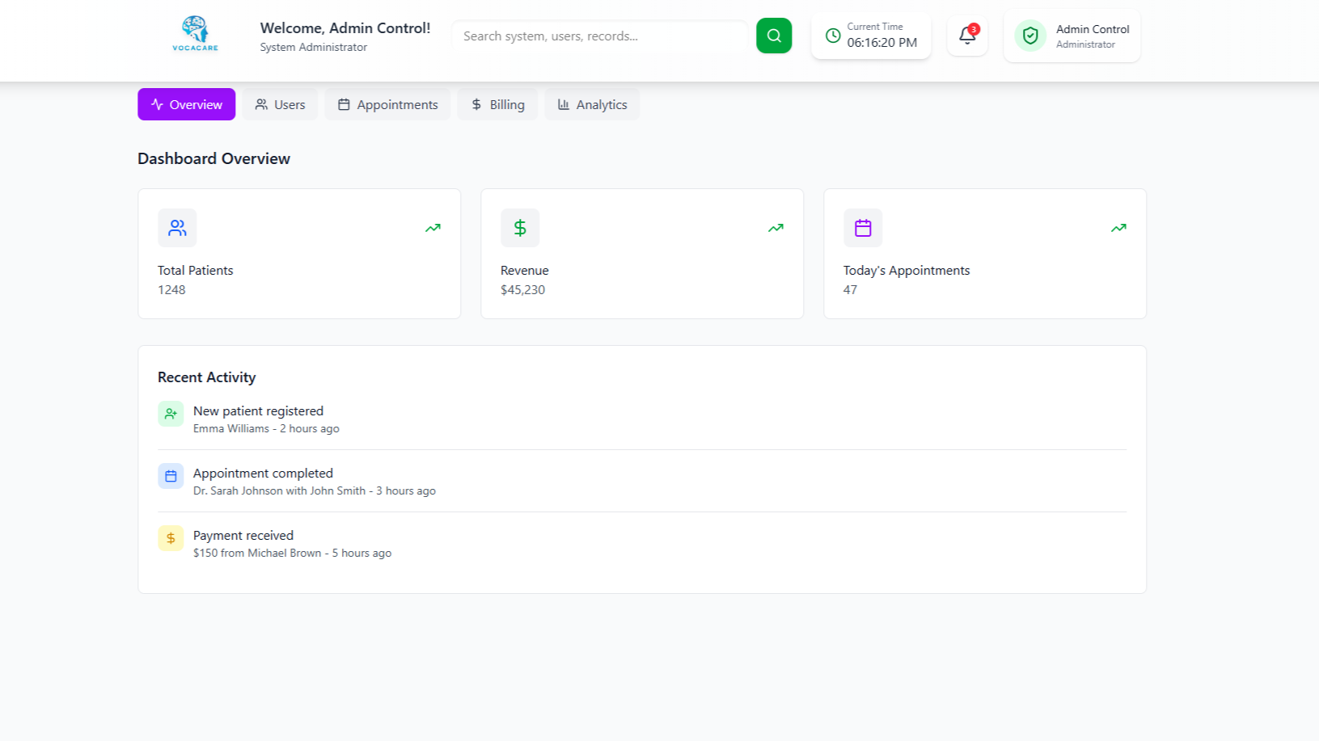

Purpose & Context
Complete management of system users, analytics, departments, billing, logs.

Element Details

Header
- Welcome admin
- Global search (search users, departments, roles)
- Current time
- Notifications
- Admin menu

Main Sections
- Overview
- Users
- Appointments
- Billing
- Analytics

User Flow

1. Admin uses global search
System Action:
- Search across:
  - users
  - doctors
  - receptionists
  - departments
  - logs
- Click result → navigate to detail page

2. Admin adds a user
System Action:
- Open create-user modal
- Fill details
- Save → User list refreshes

3. Admin views analytics
System Action:
- Load charts (appointments, revenue, user activity)
- Switch timeframe filters

4. Admin edits system roles
System Action:
- Open role editor
- Assign permissions
- Save updates

5. Notifications dropdown
System Action:
- Mark events as read

6. Logout
System Action:
- Clear session
- Redirect to login

References

Ref. No. | Document Title | Date of Release/ Publication | Document Source
PGBH01-2025-Proposal | Project Proposal | Sep 23, 2025 | https://github.com/Hospital-Information-Management-System/Capstone/tree/main/Project%20Proposal
PGBH01-2025-FS | Functional Specification | Oct 11, 2025 | https://github.com/Hospital-Information-Management-System/Capstone/tree/main/Project%20SRS
PGBH01-2025-FS | Design Document | Dec 6, 2025 | https://github.com/Hospital-Information-Management-System/Capstone/tree/main/Project%20Design%20Document

